Scratch exercises

Getting started tutorial

1. Instructions: go to <https://scratch.mit.edu> and type in “VACompSciSOLs” into the search bar and press enter.

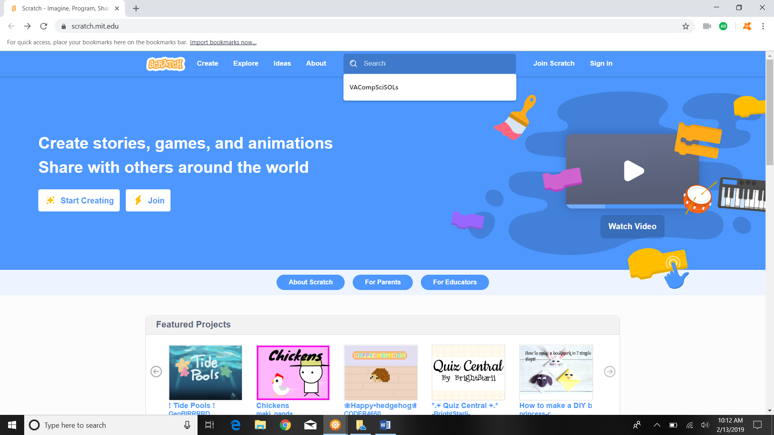

1. Click on “Blank Project”

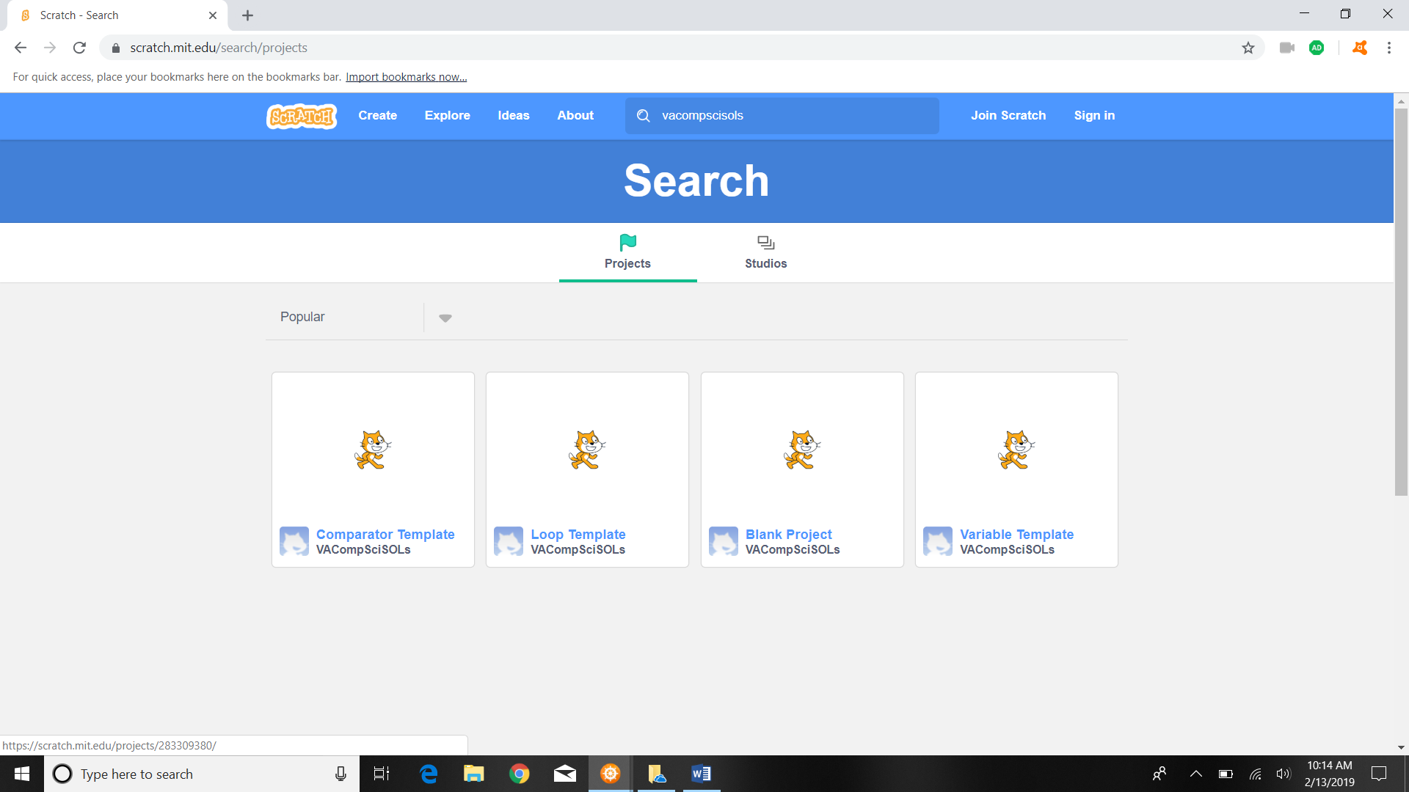

1. Then click the see inside button.

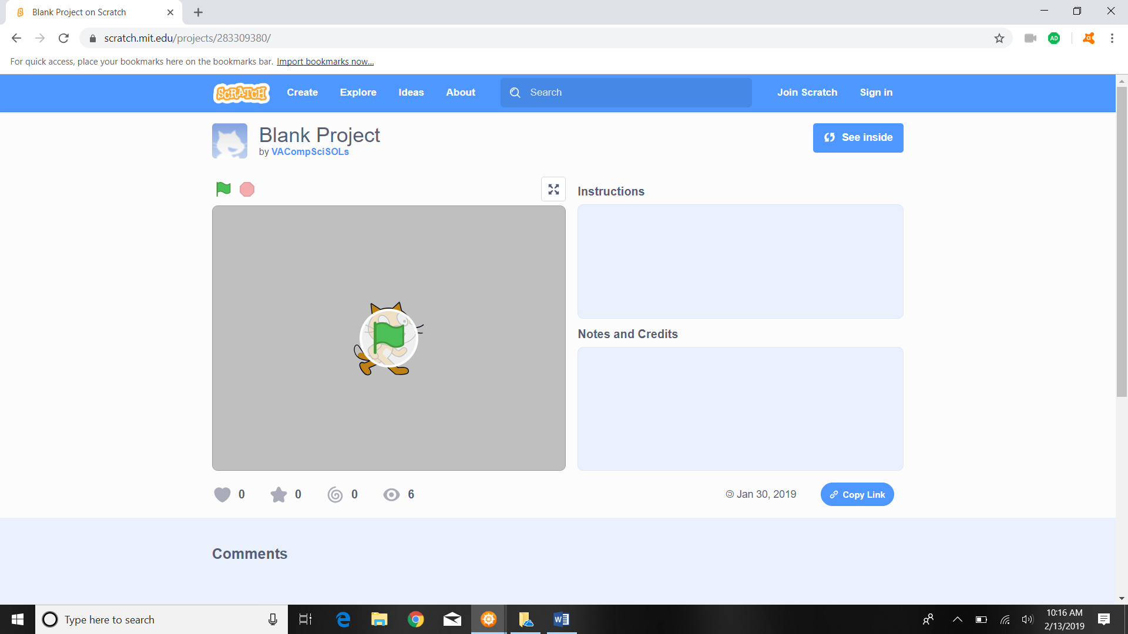

1. The “code” in Scratch is on the left panel

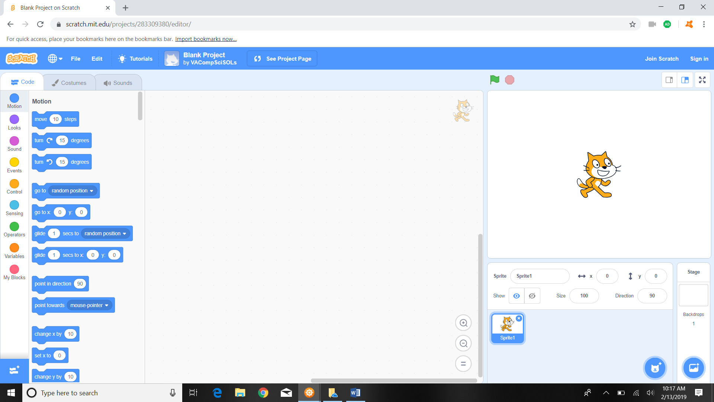

1. The “code” contains different actions which can be scrolled to or jumped to quickly using the buttons such as “motion”, “looks”, “sound”, “events”, etc.

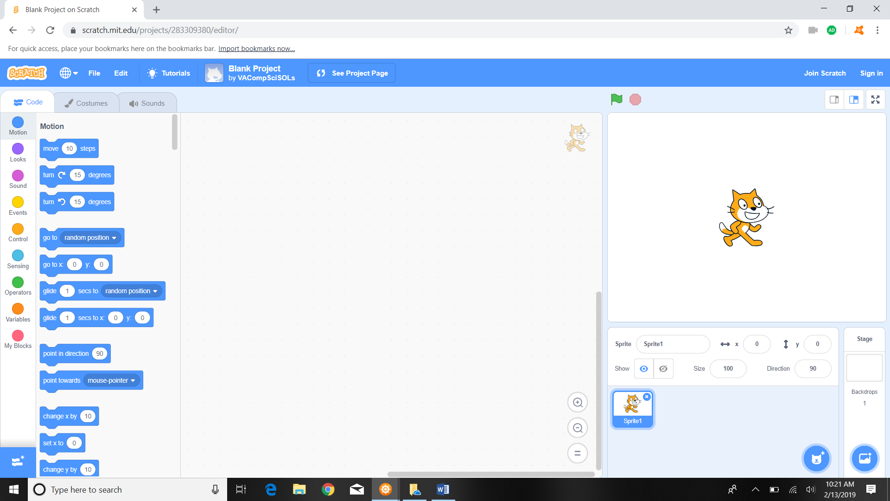

1. Code is “dragged” from the code panel into the middle panel by clicking an action with the mouse, holding and dragging the action until it is in the middle panel, and unclicking or releasing the mouse click while the action is in the middle panel.

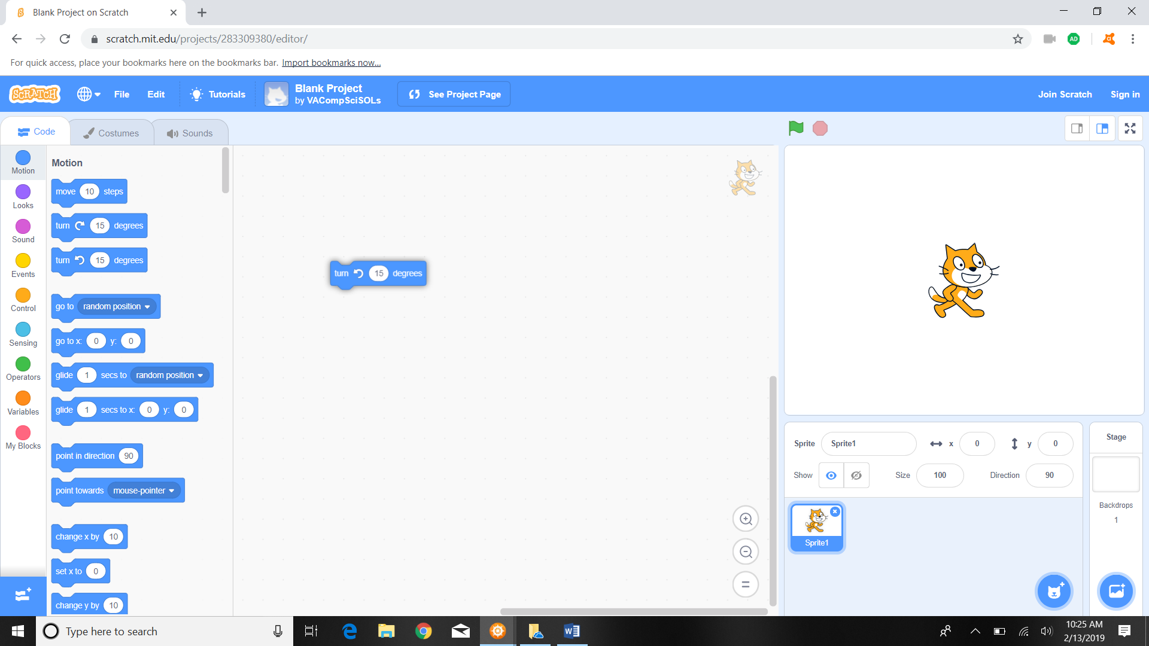

1. To “delete” or remove code click on the action segment in the middle panel you wish to remove and drag the action segment back to the left panel.

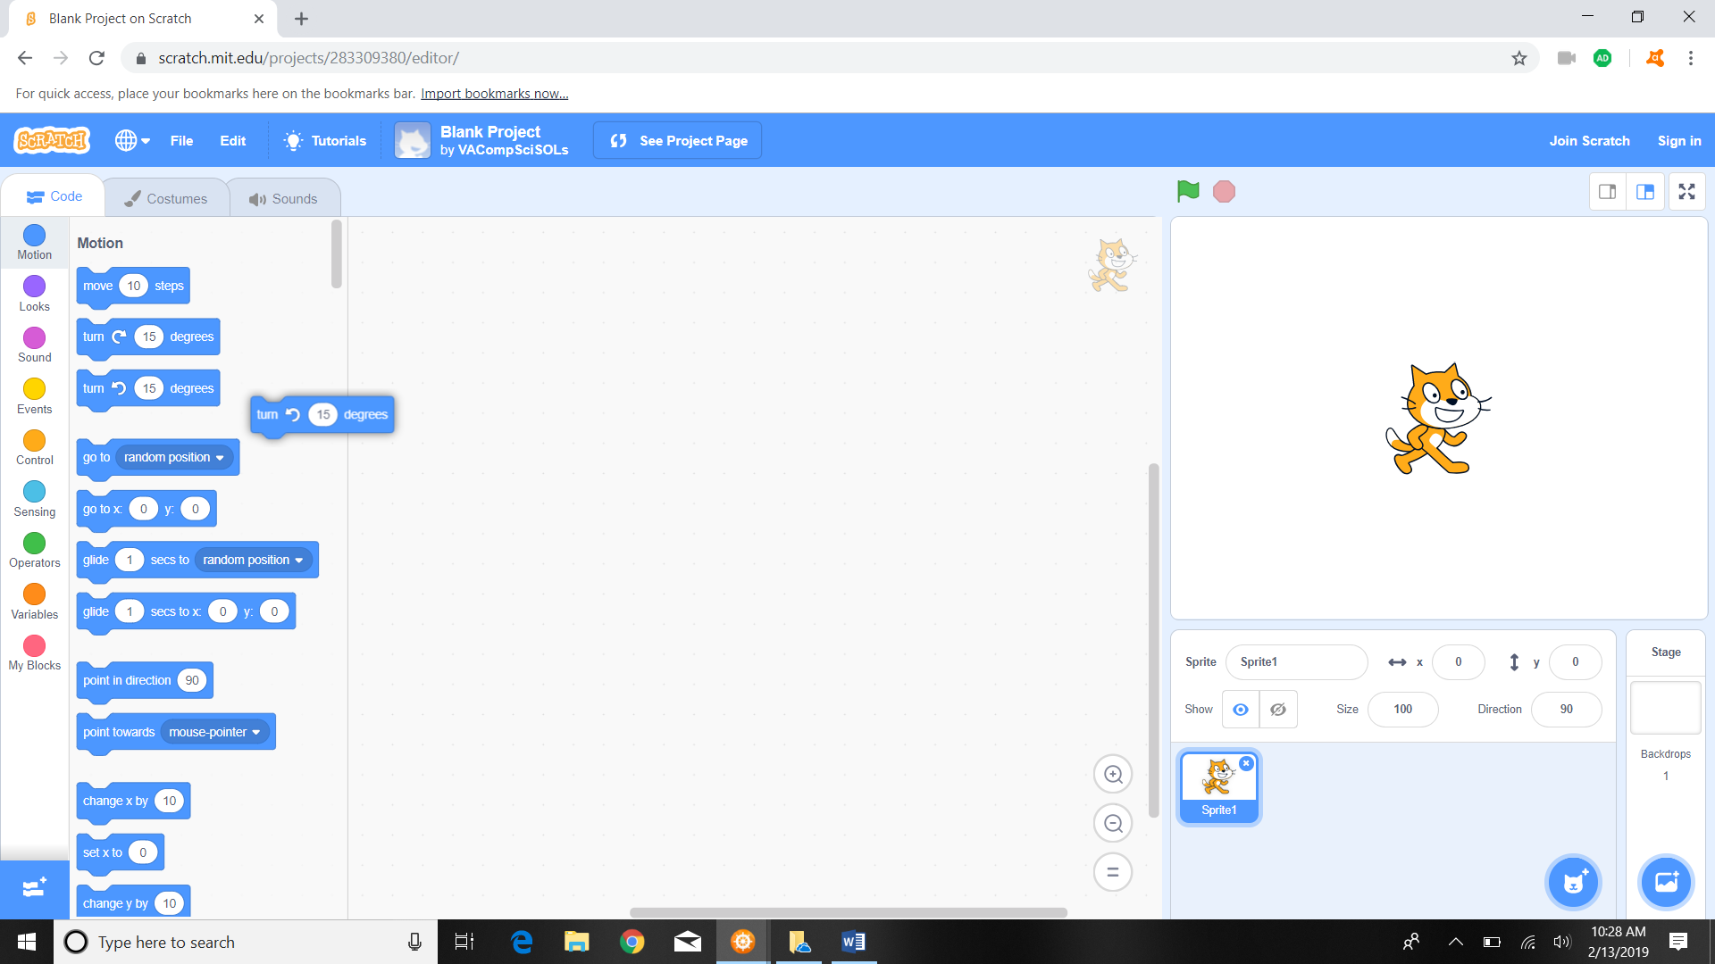

1. The user designed code created in the middle panel must know when to “start”. As such, the code must begin with the proper action piece. In Scratch the piece is 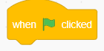 and is located in “events” section and look as follows:

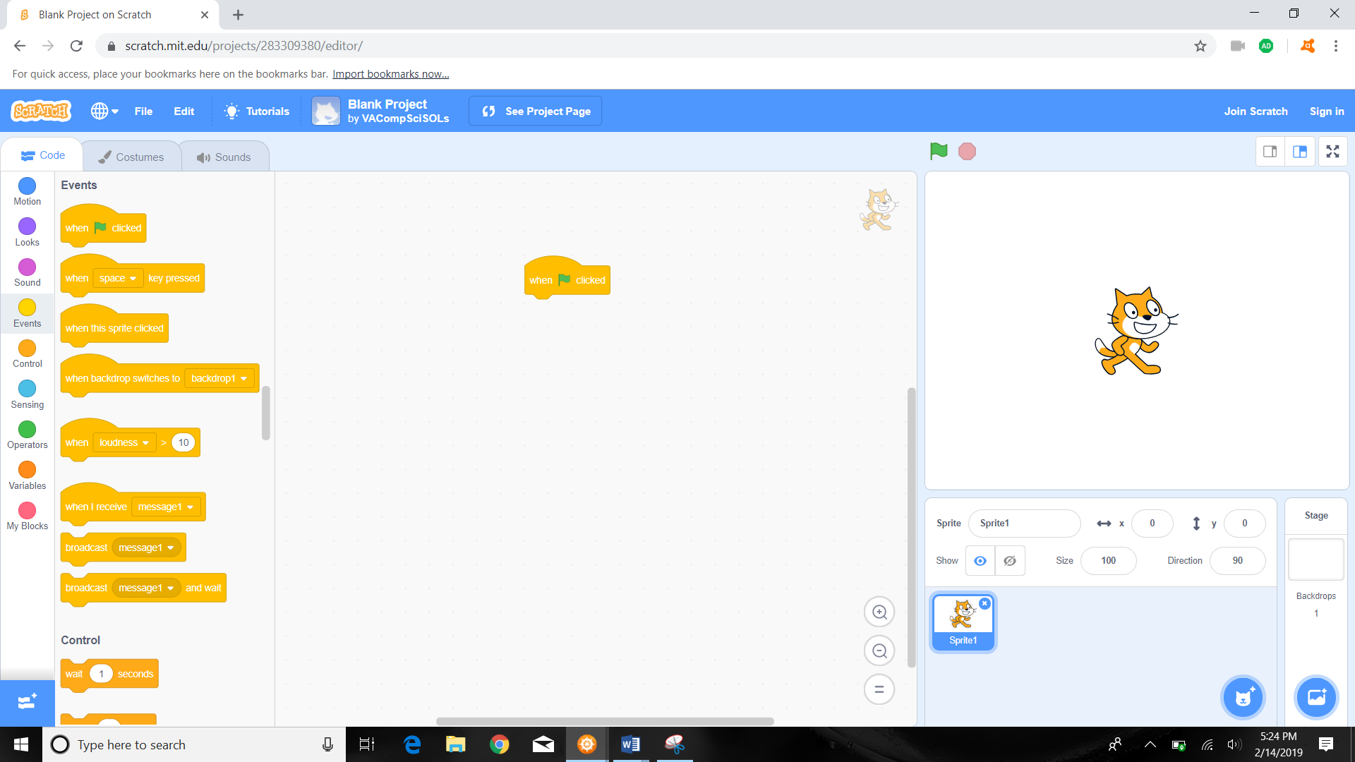

1. In order for the code to work, the action pieces must be “linked” together by fitting the puzzle pieces together. The screenshot above shows an “unlinked” chain and would not run. Below is a screenshot of the start and stop actions “linked”.

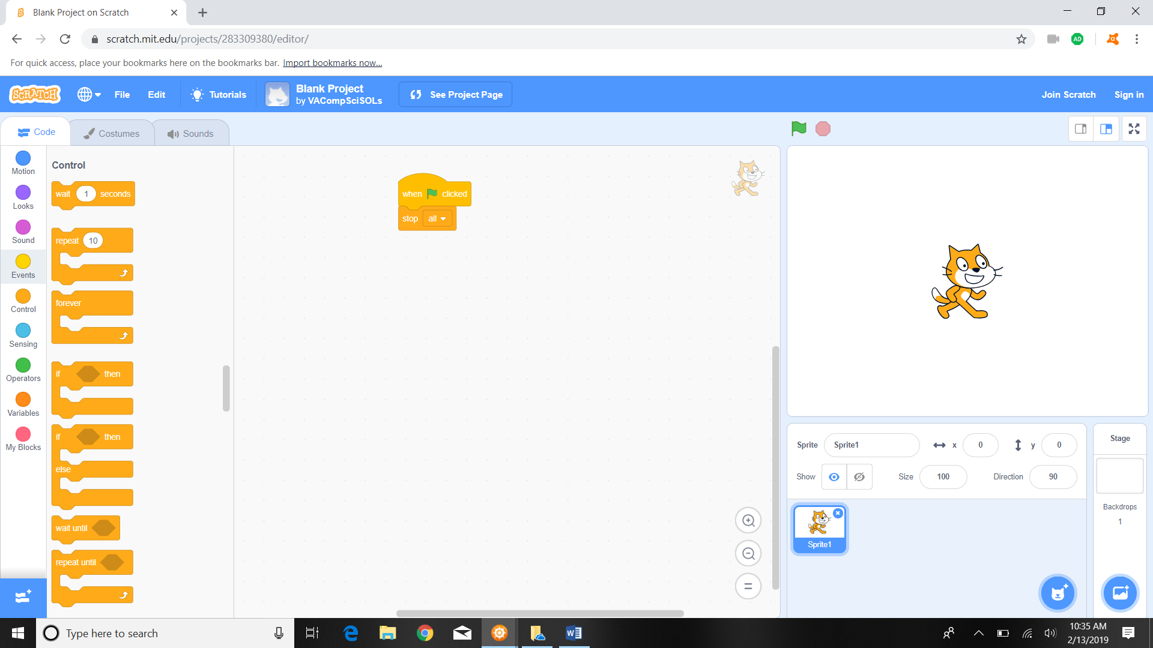

1. To “run” the code, press the green flag. Code that is incomplete/incorrect may need to be forcibly stopped after the green “run” code is pressed. To force stop code that is running, press the stop button that is located next to the green flag. This allows a student to fix the mistake and run the code again.

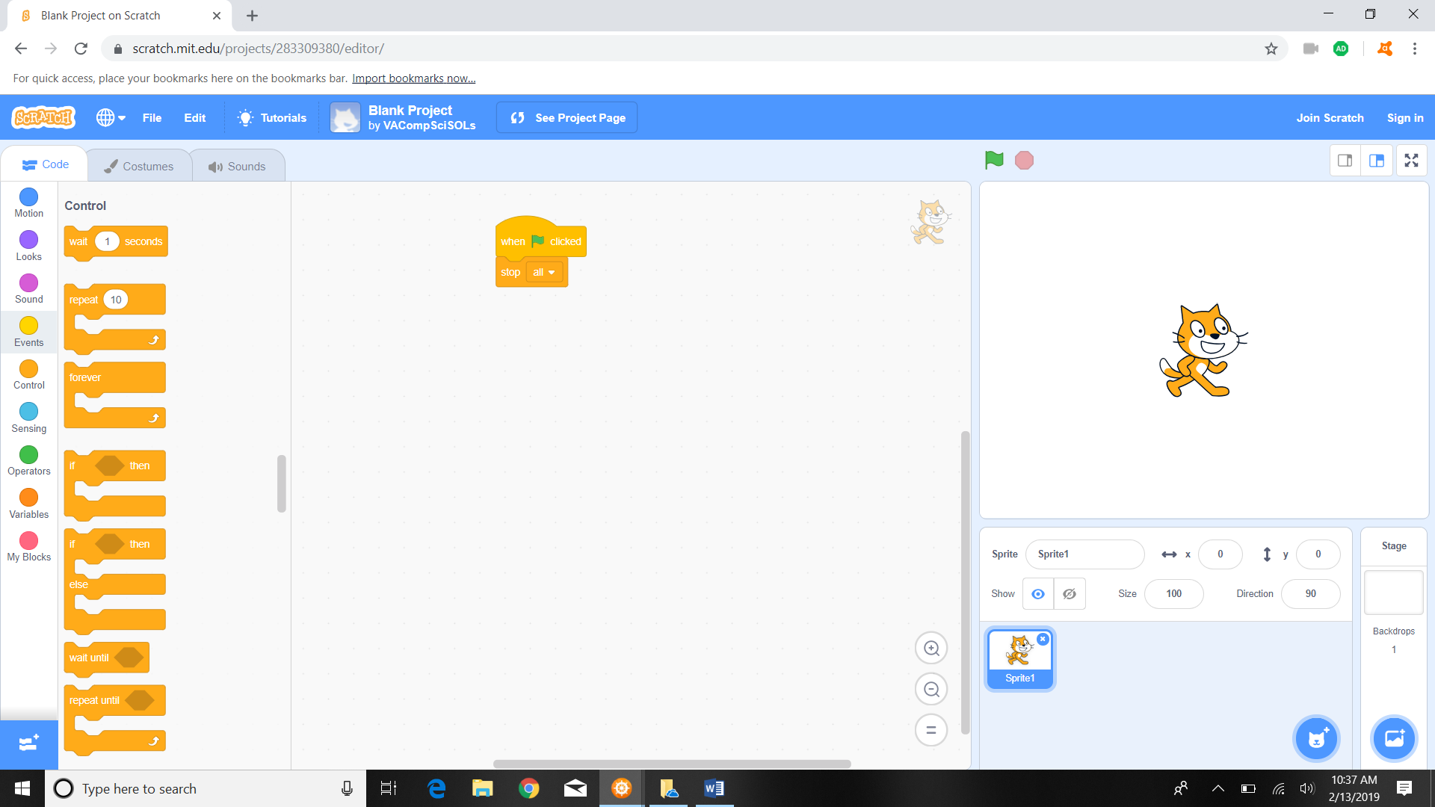

1. The scratch cat in the right panel should perform the coded actions.



1. To get familiar with Scratch, code this simple exercise (the go to random position action can be found in the “motion” section) see next picture for zoomed in code:

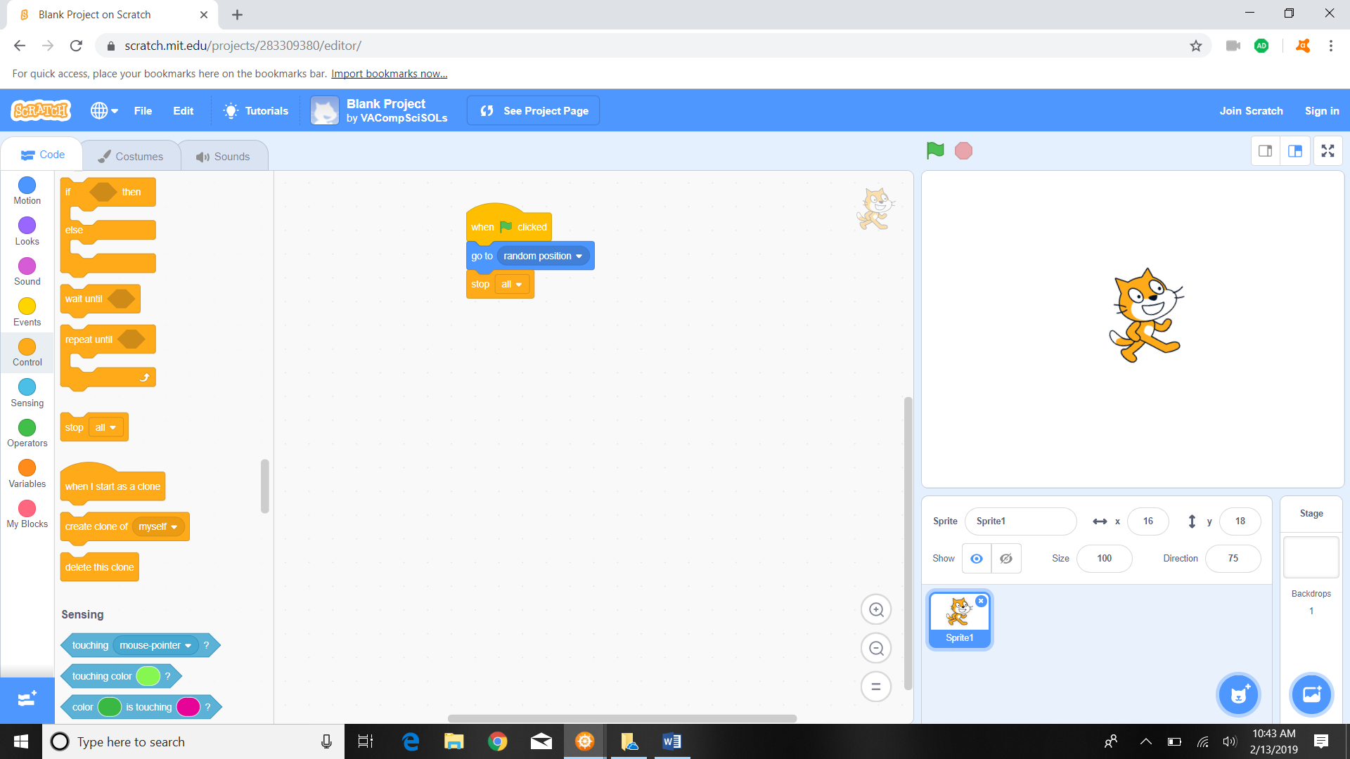

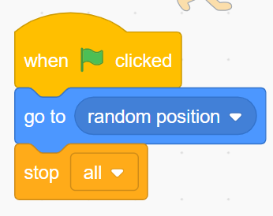

1. Once this code is linked together in the middle panel, press the green flag to run the code and the scratch cat in the right panel should move around every time the green flag is pressed.

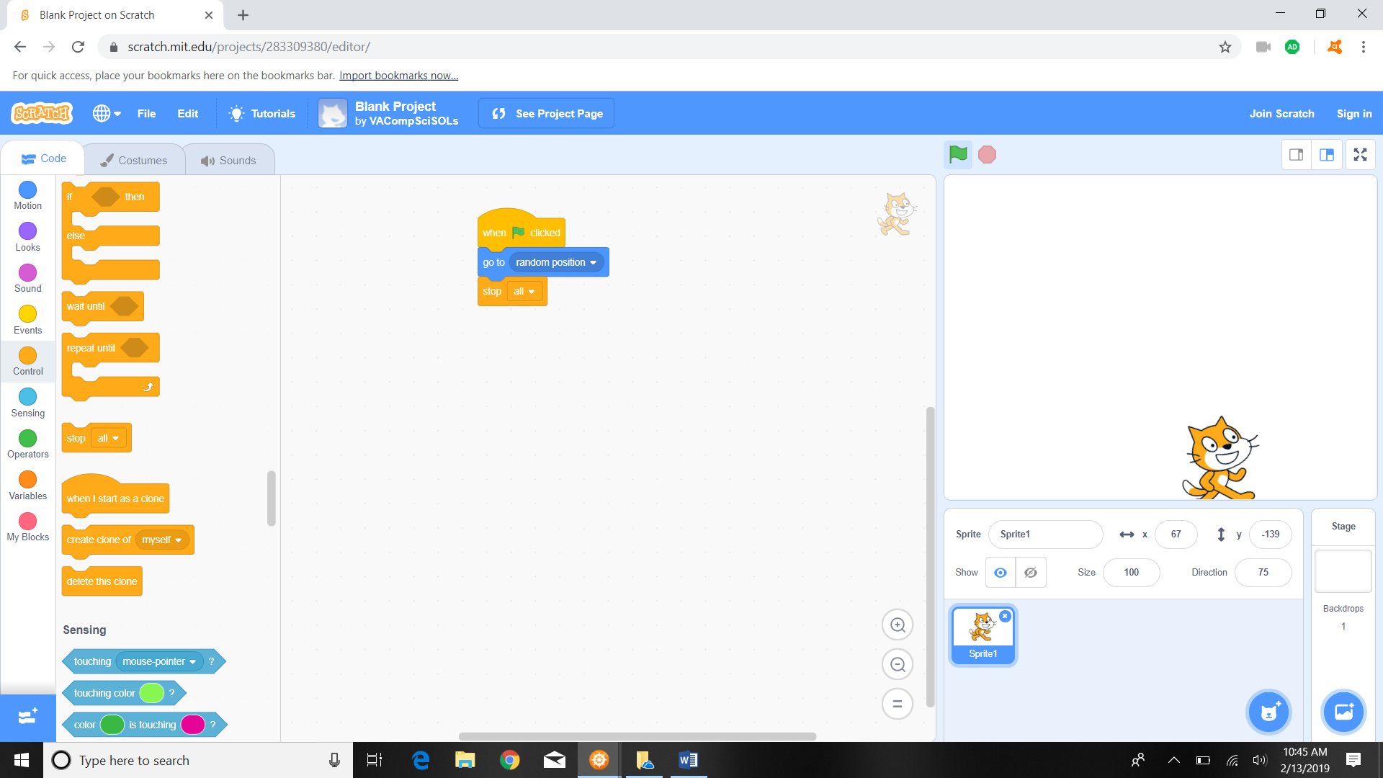

Exercise #1

Question #1

1. To begin go to <https://scratch.mit.edu> and type in “VACompSciSOLs” into the search bar and press enter.



1. Click on “Blank Project”



1. Then click the see inside button.



1. To begin, add the “start” code by going to the code section on the left and clicking on the “events” button. Drag the  action to the middle of the screen.

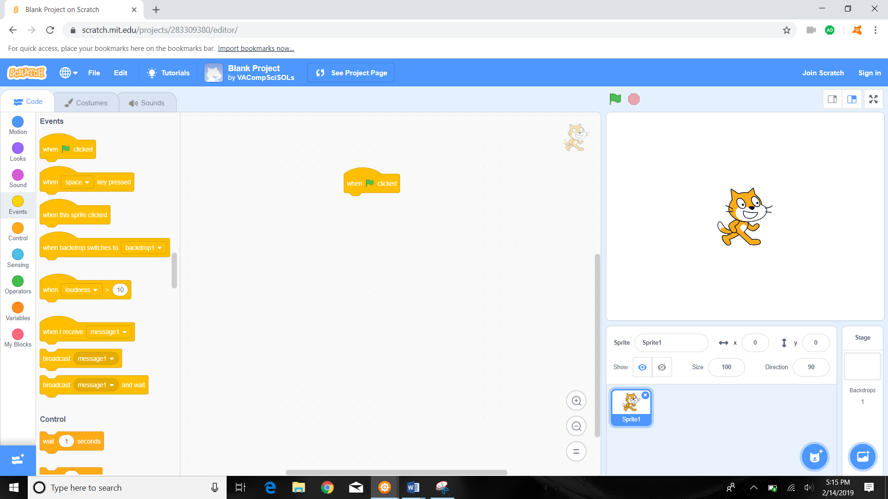

1. Next, in the code panel, click on the “looks” button 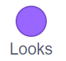 and drag the “say Hello!” piece 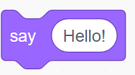 to the middle panel and snap it to the bottom of the other piece.

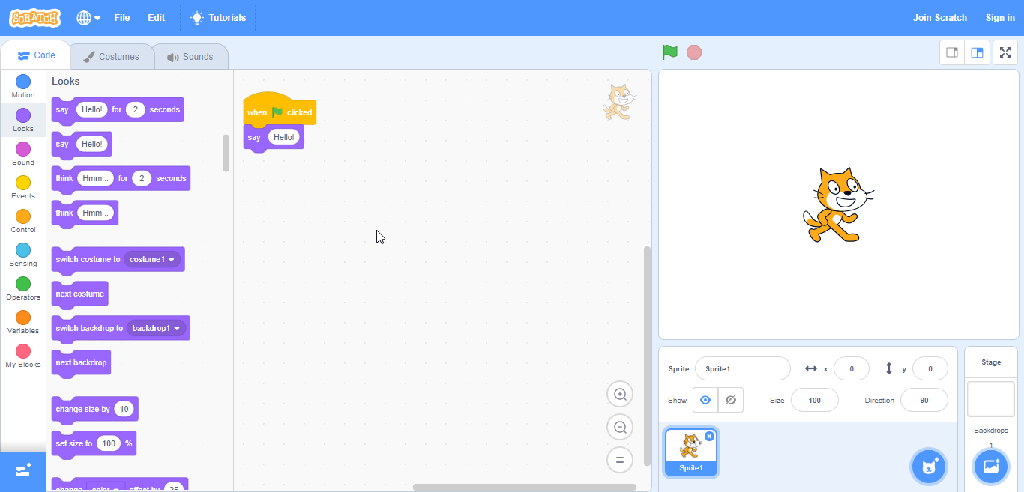

1. Click on the green flag  to run the program.

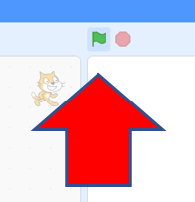

1. Students will raise their hand and show you the screen before they move on to the next question. The final screen should look like this:

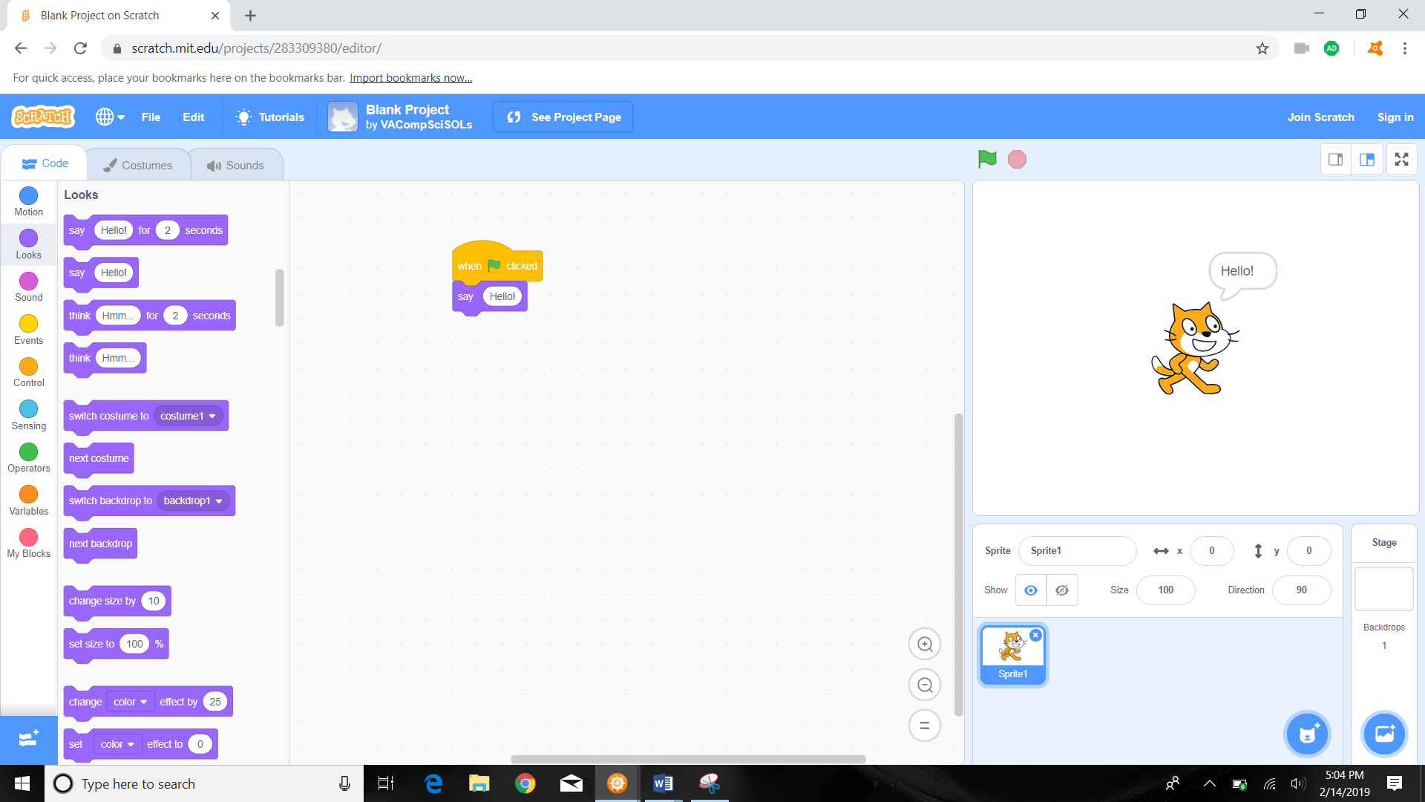

Question #2- Loops

1. We need to enter the “Loop Template”.
   1. To do so you can repeat Step 1 of Question 1 and in Step 2 of Question 1 instead of clicking “Blank Project” click “Loop Template” instead.



* 1. If you are currently in the “Blank Project” template of Question 1:
     1. click the “see project page” button.

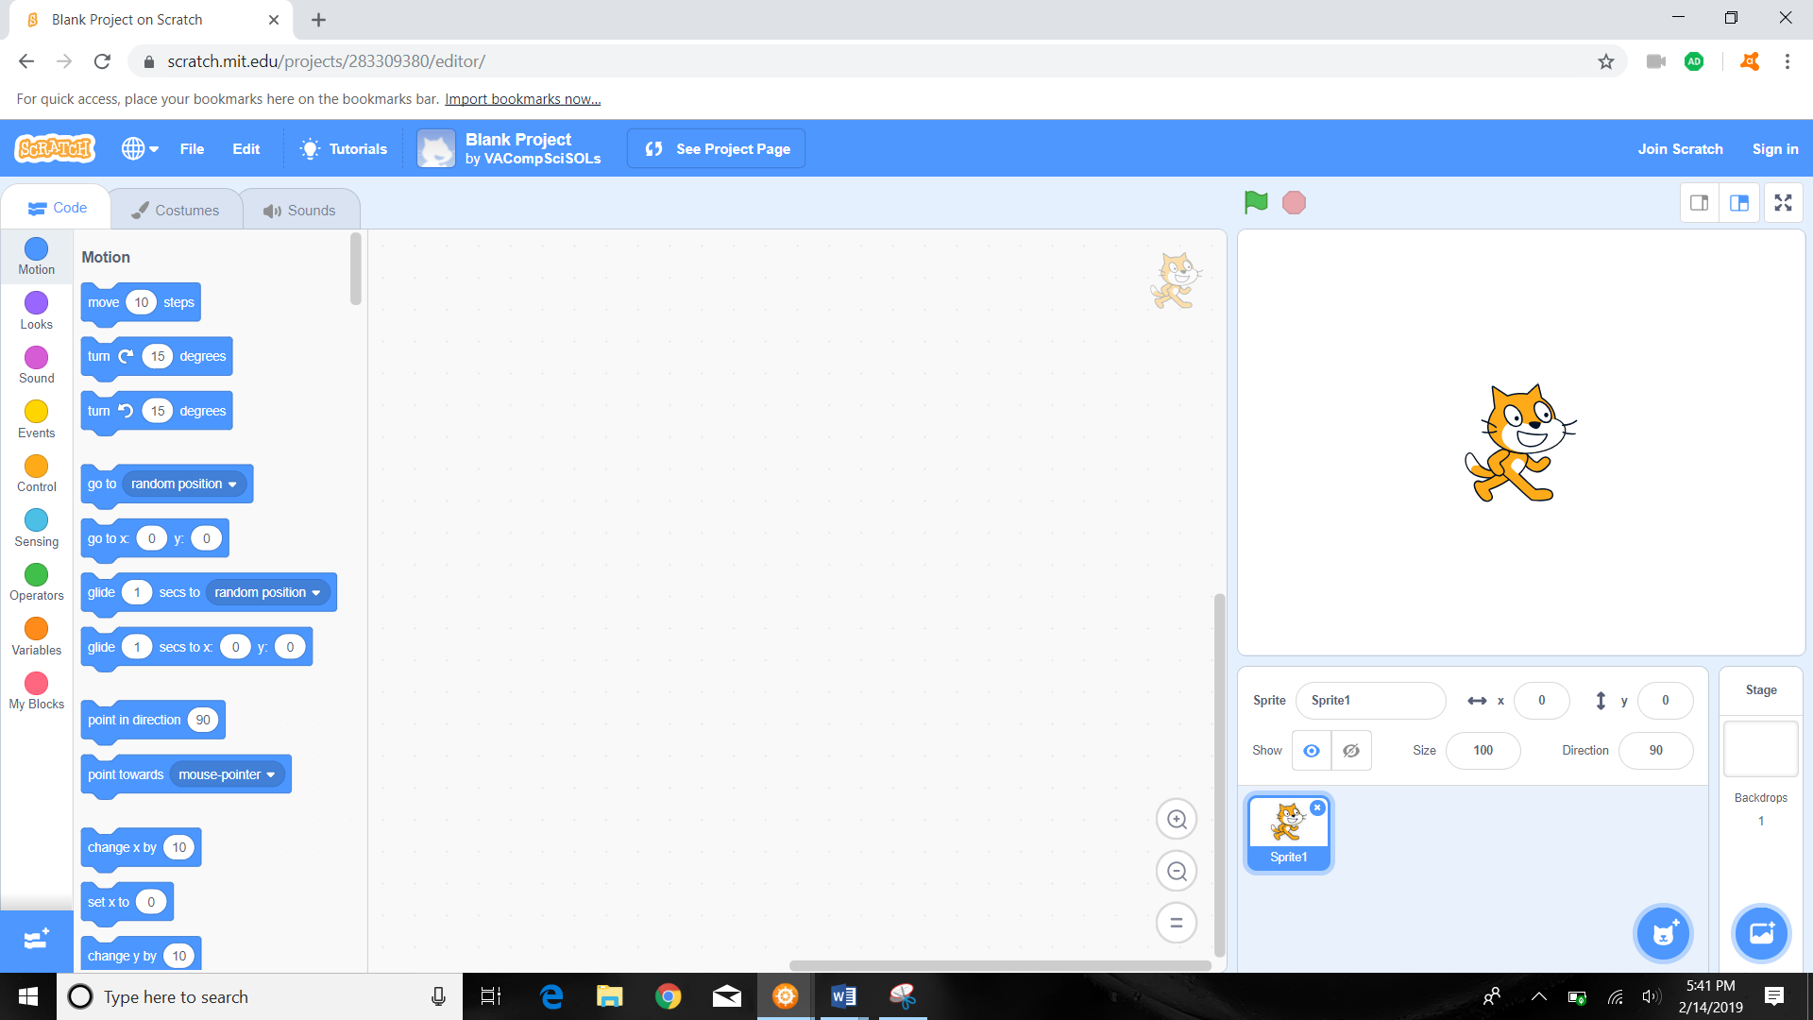

* + 1. Click the “VACompSciSOLs” link.

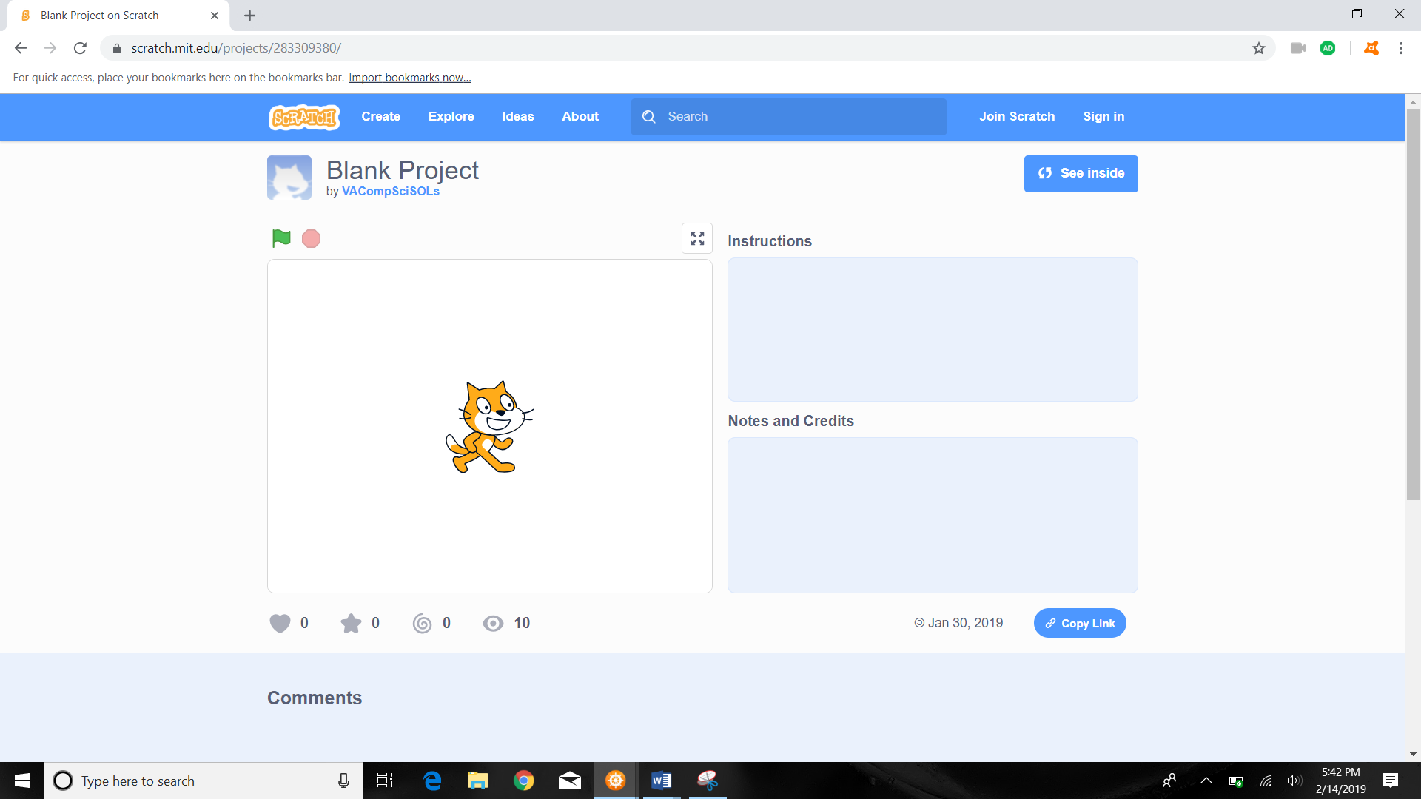

* + 1. Click on the “Loop Template” link.

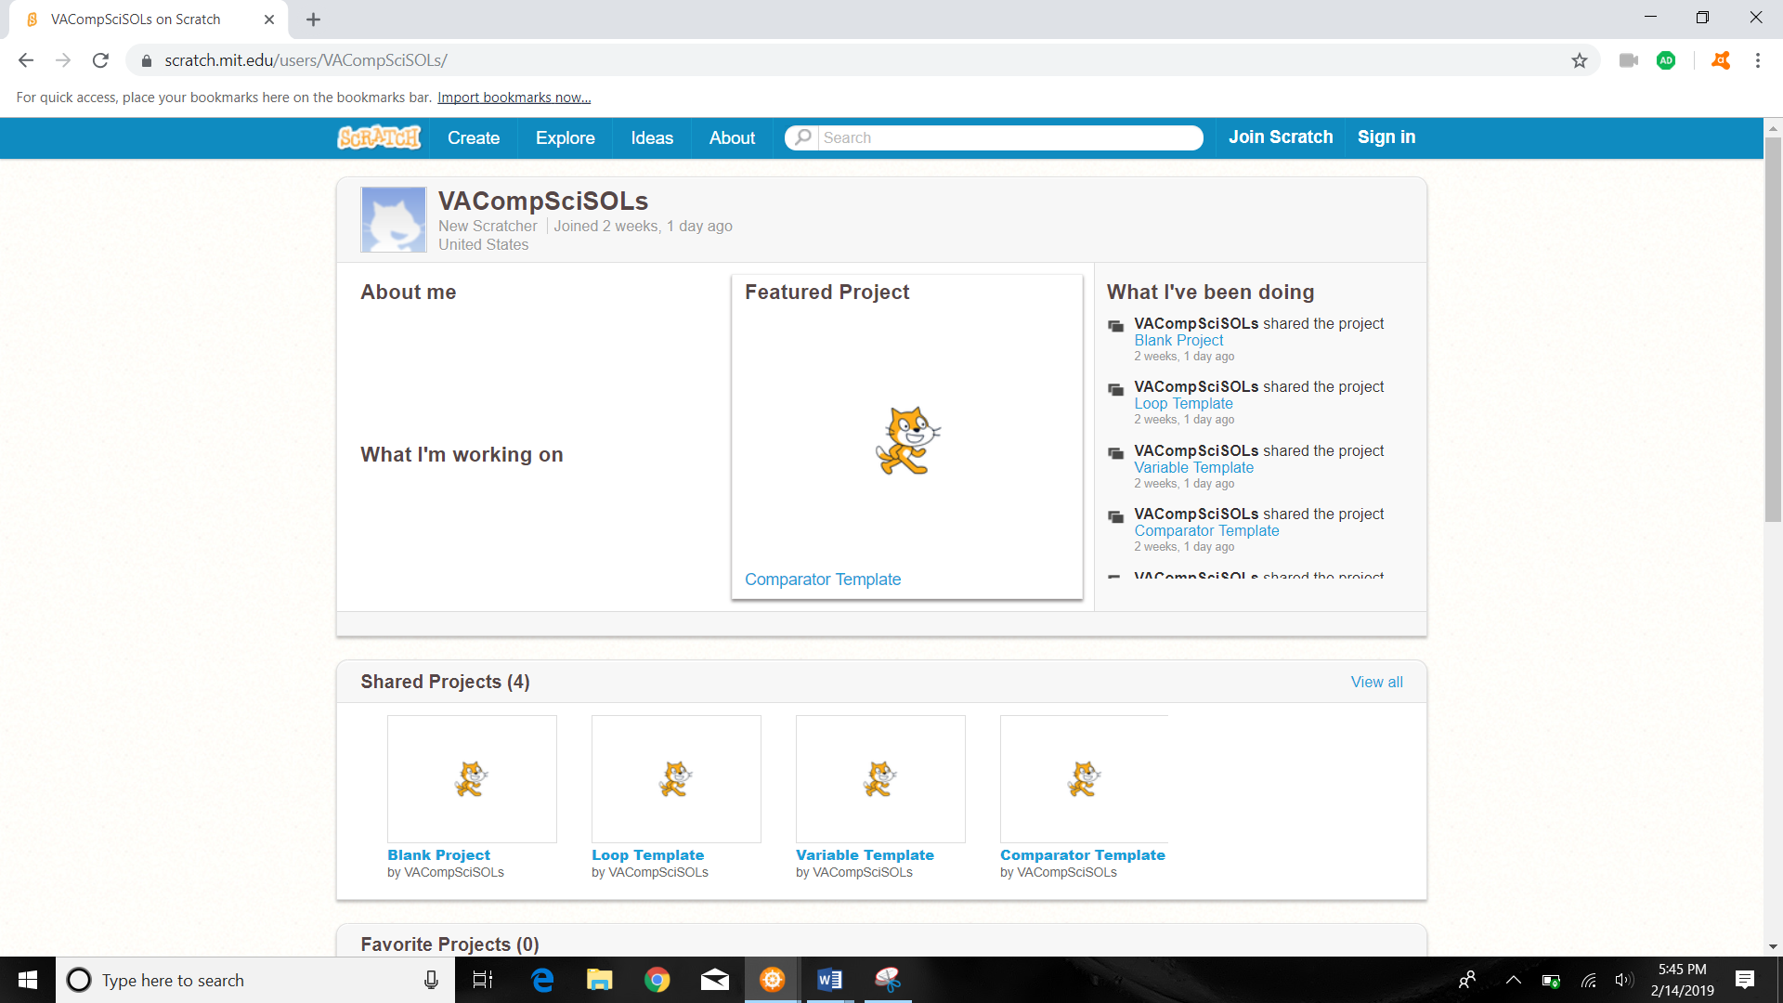

1. Click the see inside button.

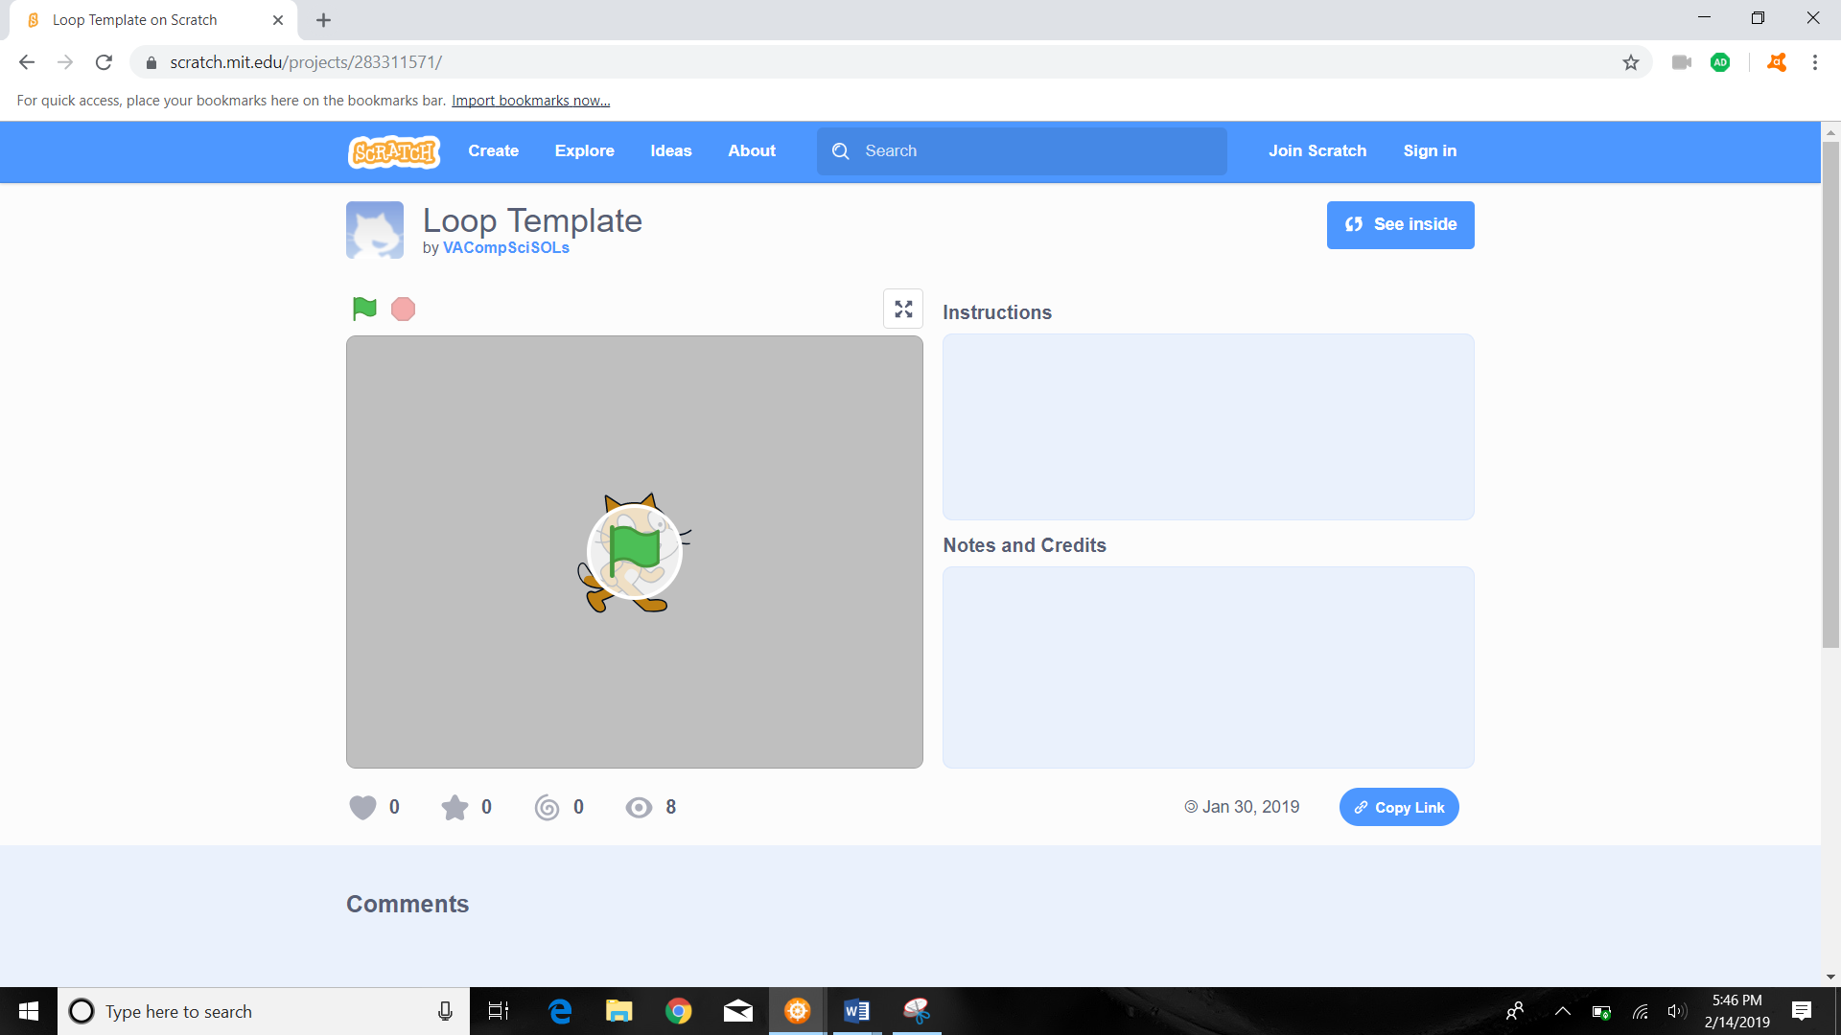

1. The default Loop Template should look like this:

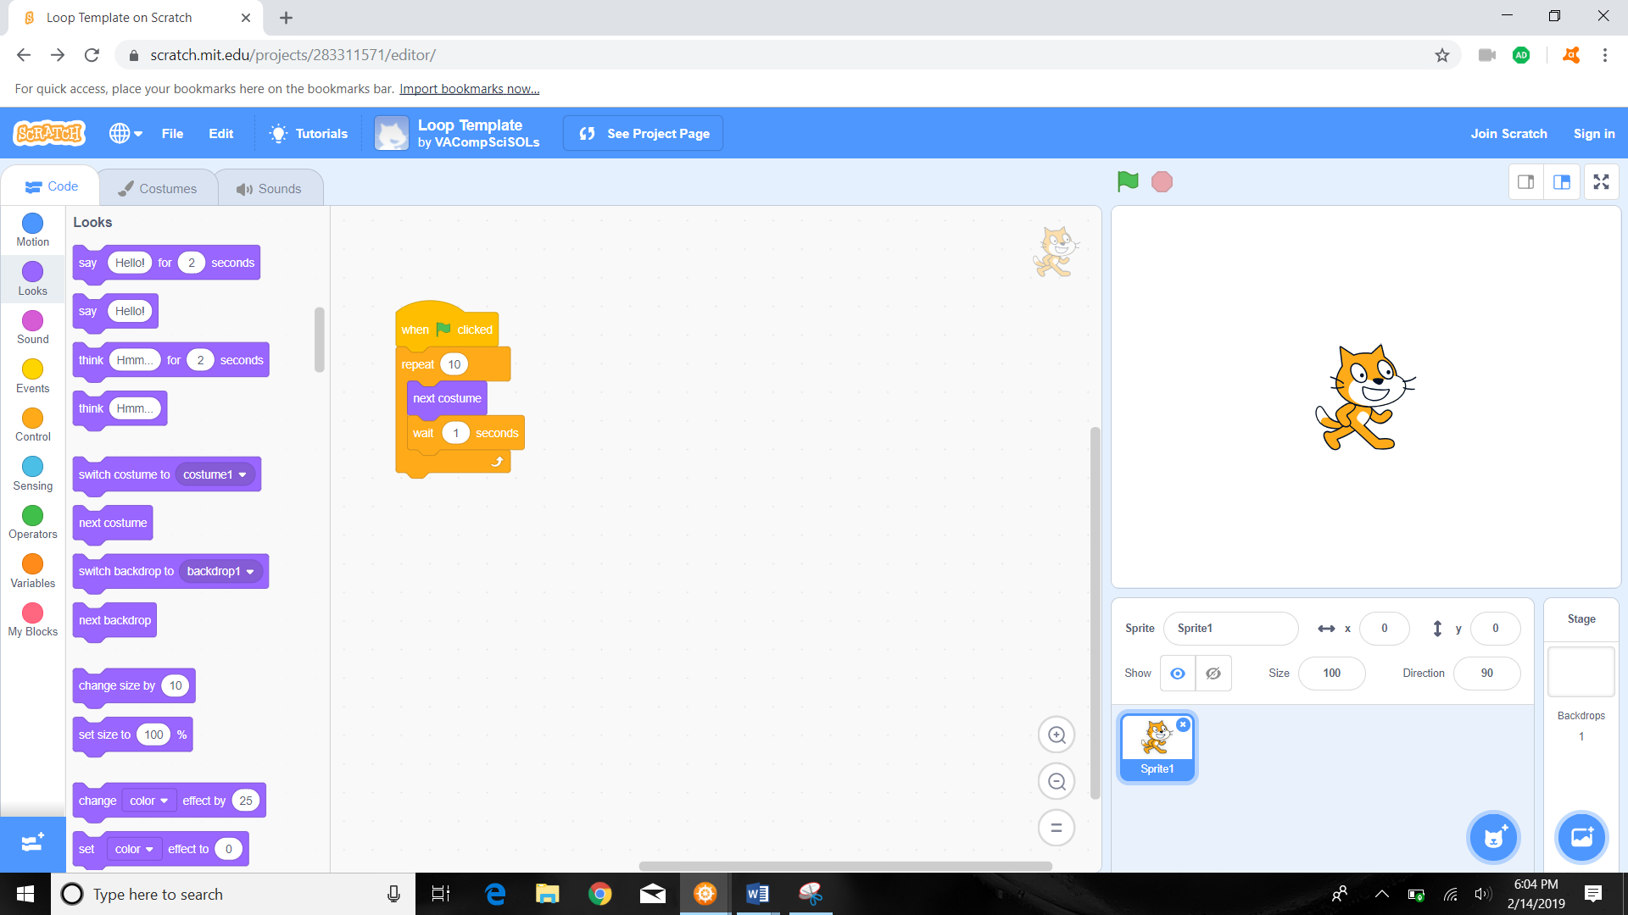

1. A loop is an instruction that repeats an action. The current instruction is coded to start when the green flag is clicked. Once clicked, the cat moves and waits one second and moves again 10 times.
2. Click on the green flag to run the program and count the number of times the cat moves.



1. Change the number “10” within the “repeat 10” to a number less than 10 and run the program again to see how the loop has changed by counting the number of times the cat moves again. For example:

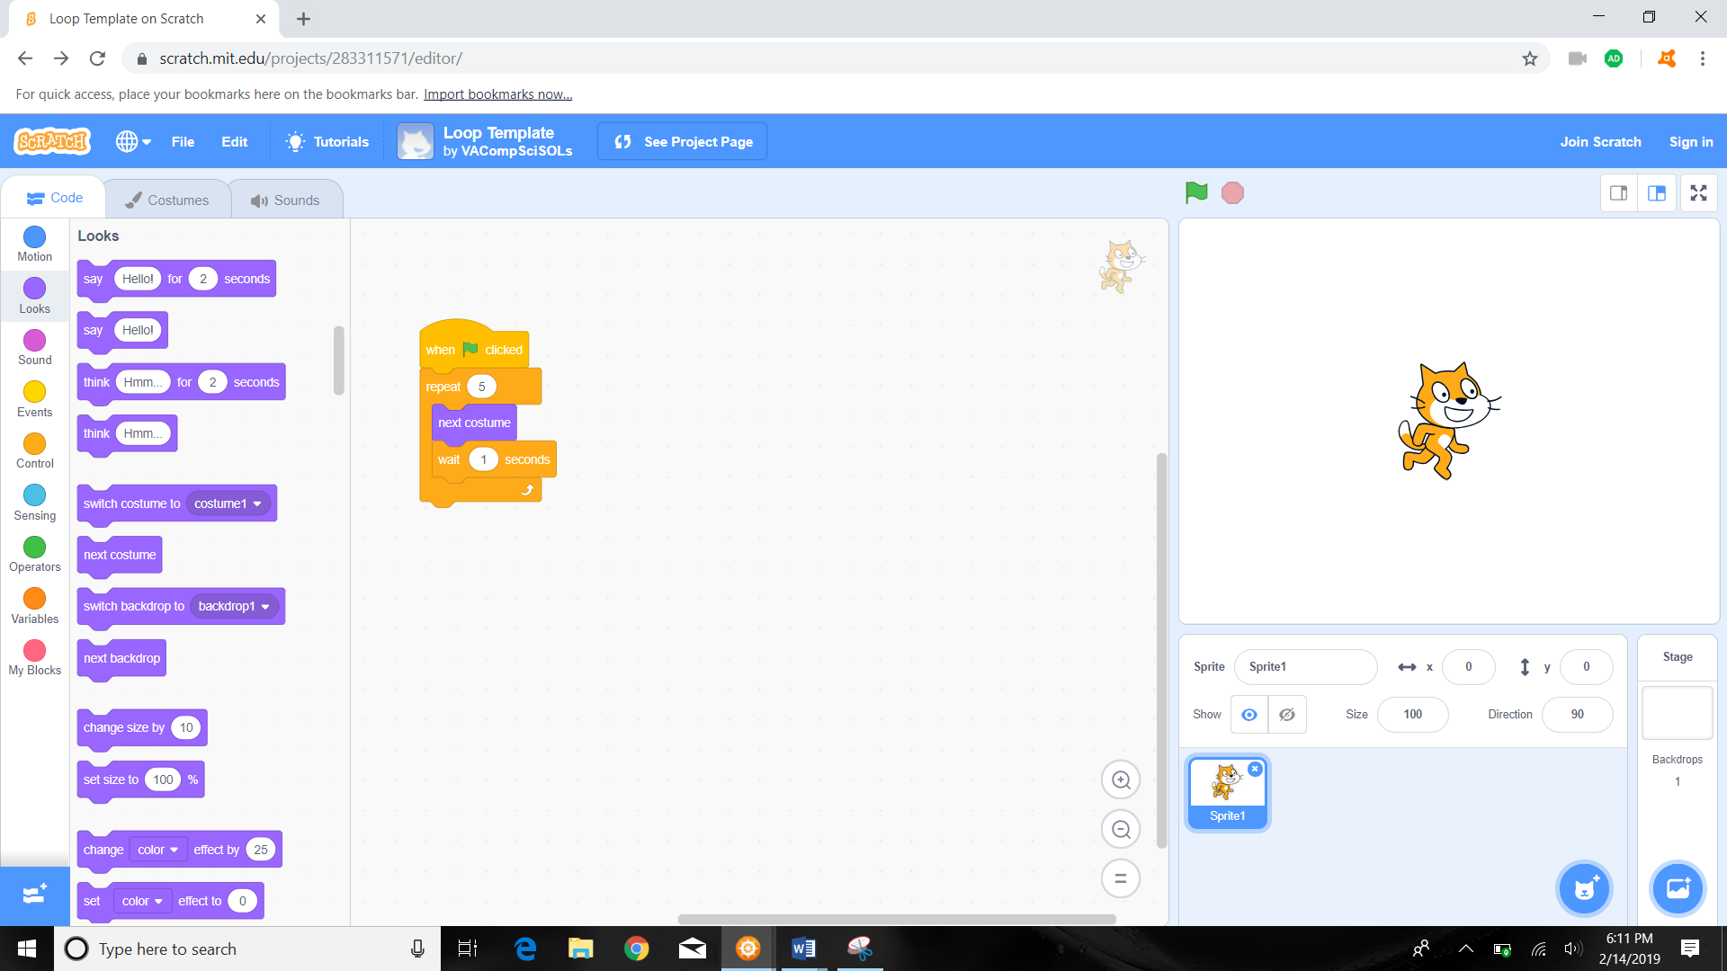

1. \*\*\*\*Student Looping Challenge\*\*\*\*: we want to rotate the cat 90 degrees 4 times. Using the provided code, remove the “next costume” action, add a turn action (located within the motion code section), and change the numbers within repeat code step to 4 and the turn code step to 90.
   1. Hint:
      1. remove 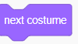 from the code
      2. change  to 
      3. add one of these actions: 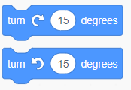
      4. Change degree in action to 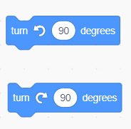
      5. make sure the  action is after the  action but on top of  action.
2. Raise your hand and show your teacher your work before you move to the next question.
3. Answer should look like (the first two pictures are zoomed in version of code from the pictures which show the full screen):

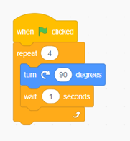 OR 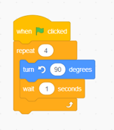

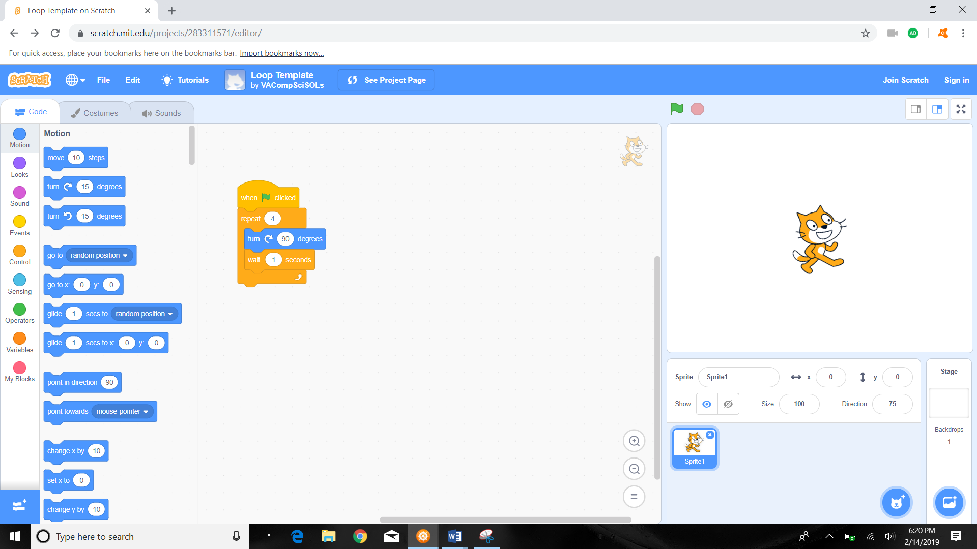

Or

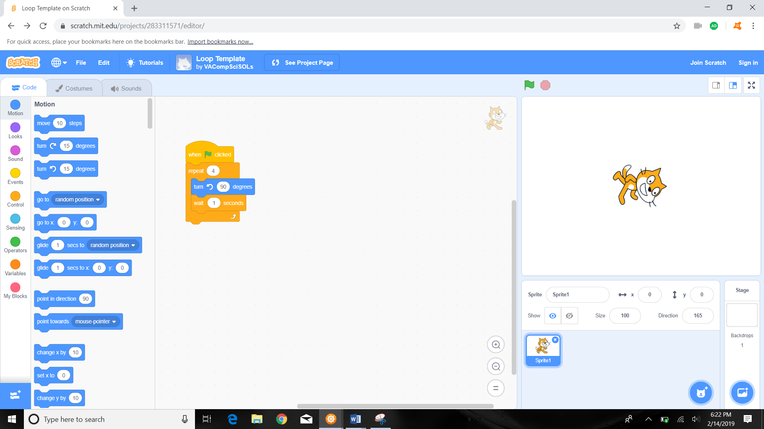

Question #3- Variables

1. We need to enter the “Variable Template”.
   1. To do so you can repeat Step 1 of Question 1 and in Step 2 of Question 1 instead of clicking “Blank Project” click “Veriable Template” instead.



* 1. If you are currently in the “Blank Project” template of Question 1 or the “Loop Template” of Question 2:
     1. Click the “see project page” button.



* + 1. Click the “VACompSciSOLs” link.



* + 1. Click on the “Variable Template” link.



1. Click the see inside button.

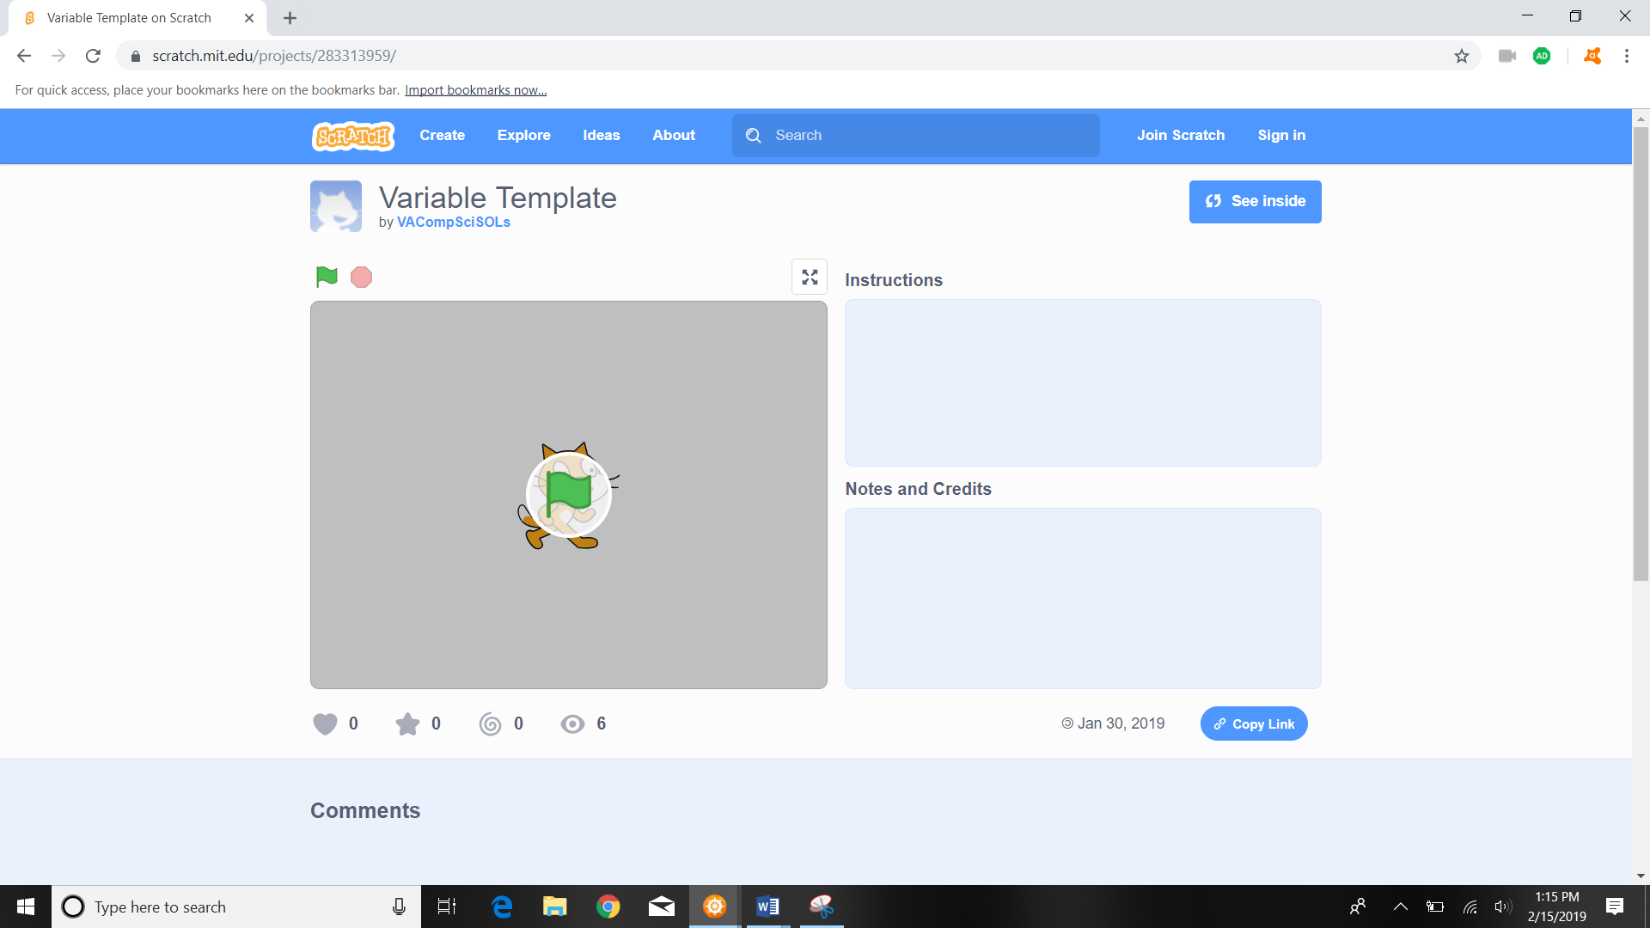

1. The default Variable Template should look like this:

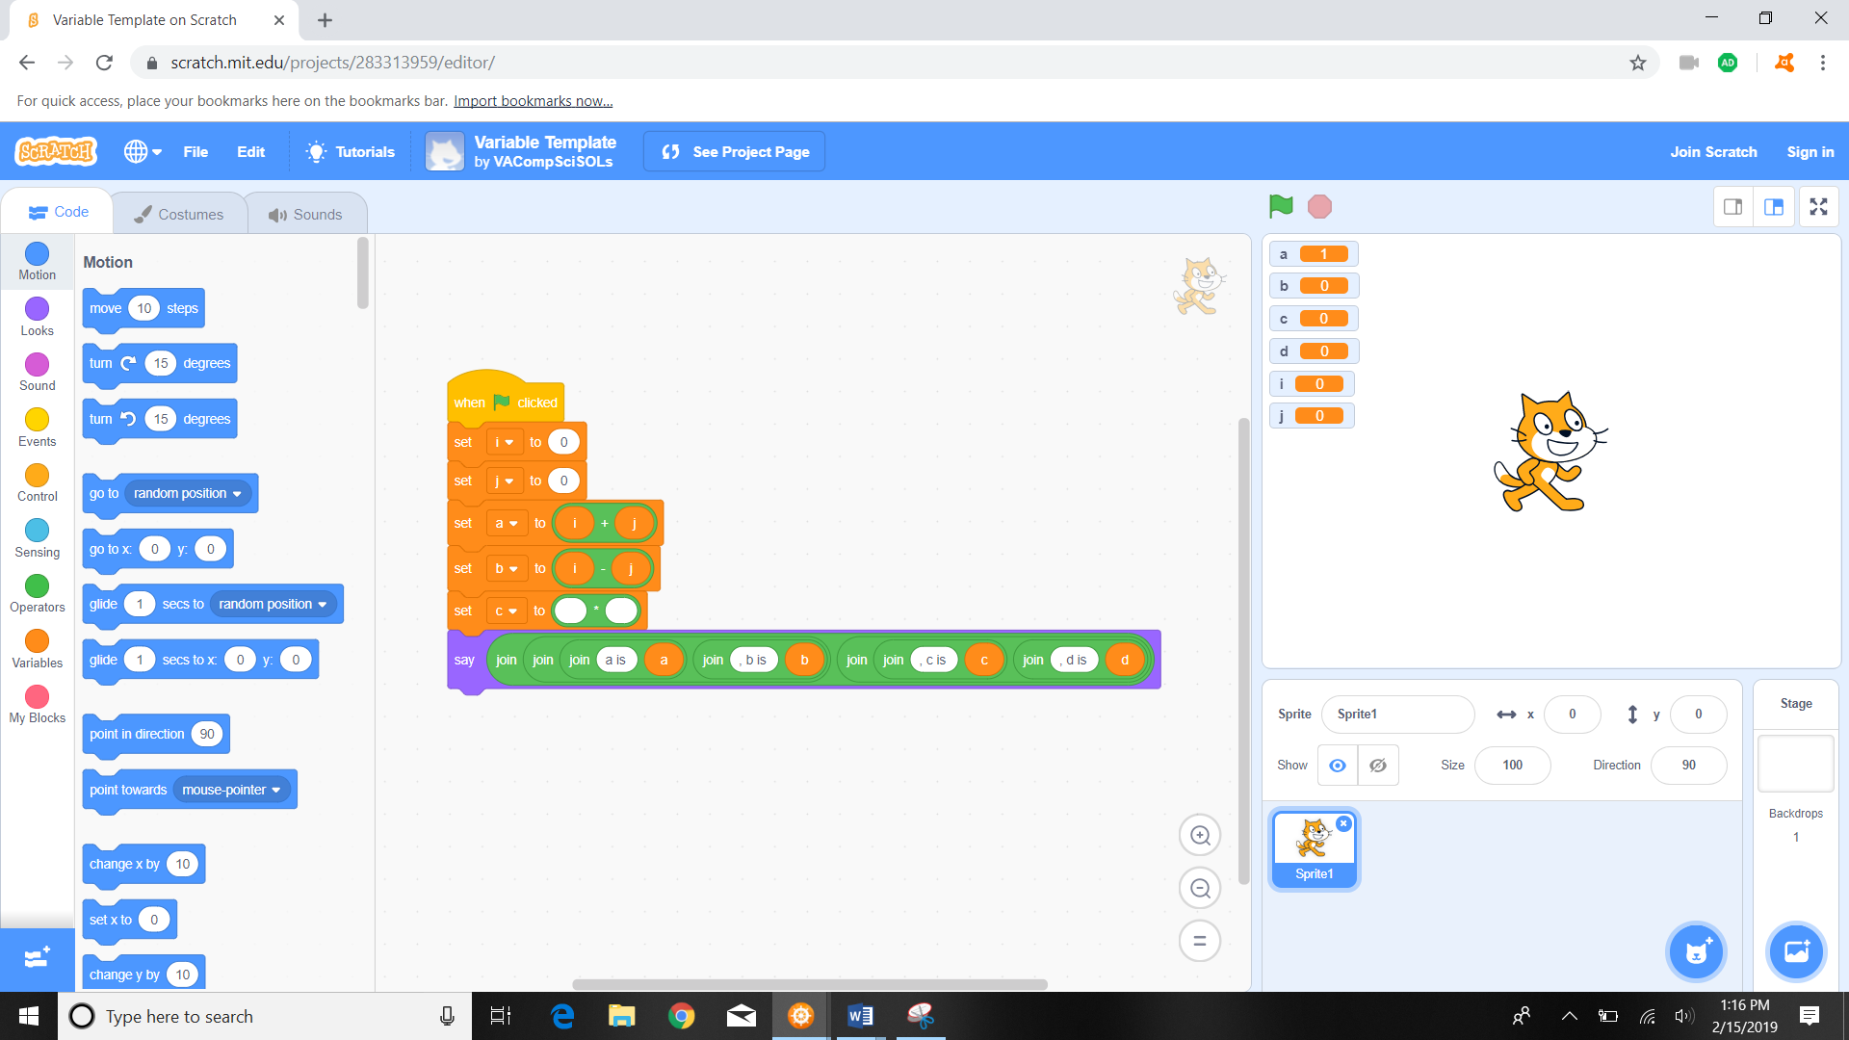

Zoomed in default code:

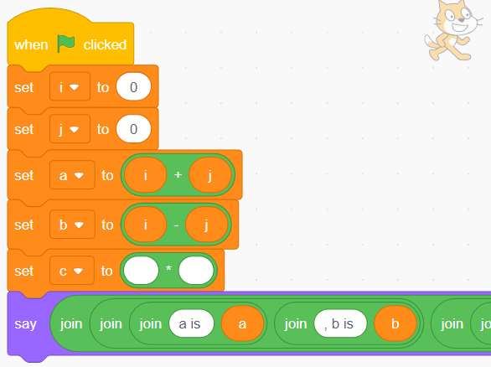

1. Click on the green flag  to run the program and see what changes on the screen.

  


1. Notice that once the green flag is clicked on and the program runs, the numbers displayed in the right panel change and the cat speaks.

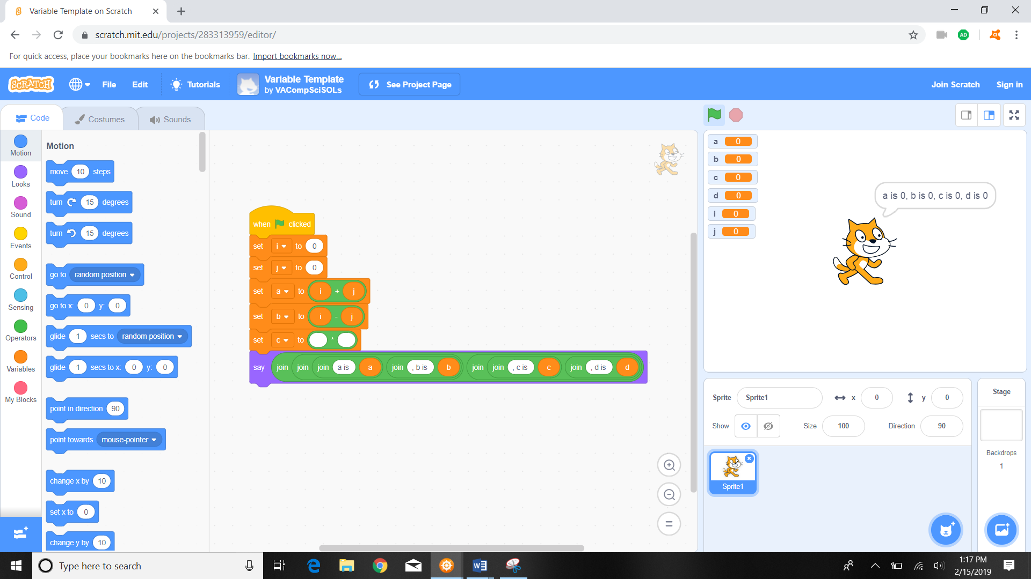

1. \*\*\*\*Student Variable Challenge\*\*\*\*: we want to change the i and j variables to different numbers (currently both i and j are set to 0).
   1. In the coding panel, click on the action button 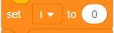 and delete the zero and change to the number 2 
   2. Do the same on the action button 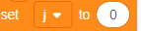 and delete the zero and change to the number 4 

Instructor: Code should look like this-

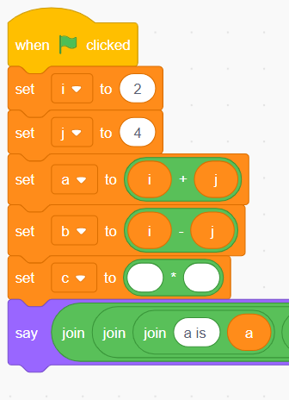

1. Click on the green flag  to run the program and see what changes on the screen.

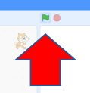

1. Notice the changes that happen once the green flag is clicked on and the program runs.

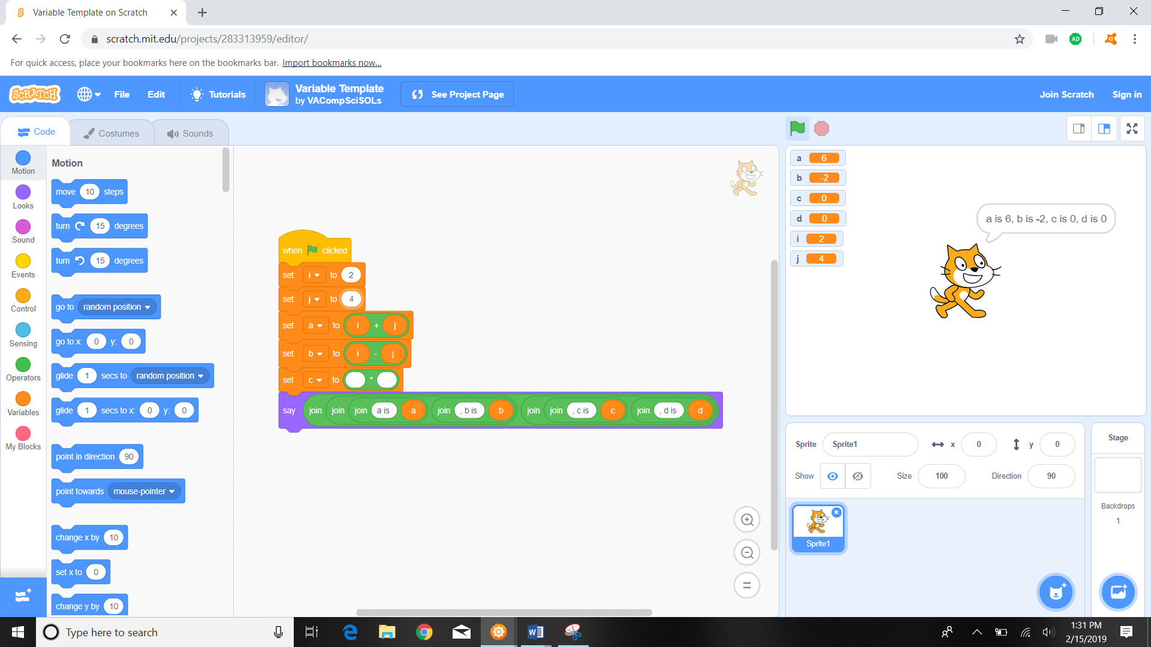

Zoomed in:

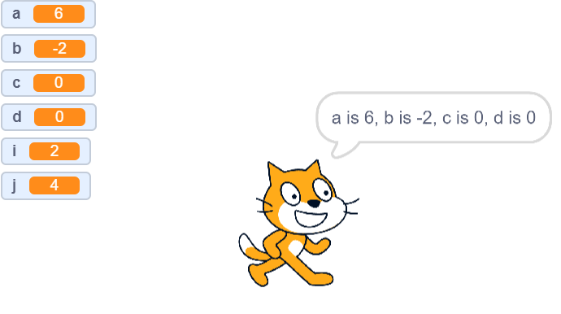

1. Why does the cat panel show that a = 6 and b= -2?
   1. Hint: look in the middle coding pane, specifically at this code:

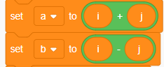

1. We are now going to code in the middle coding panel. We want to set c to i\*j. In order to do so we must complete the coding action 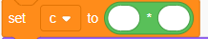 that is already in the middle coding panel.
   1. First on the left most “code” panel we must select the variables button to reveal the variable options:

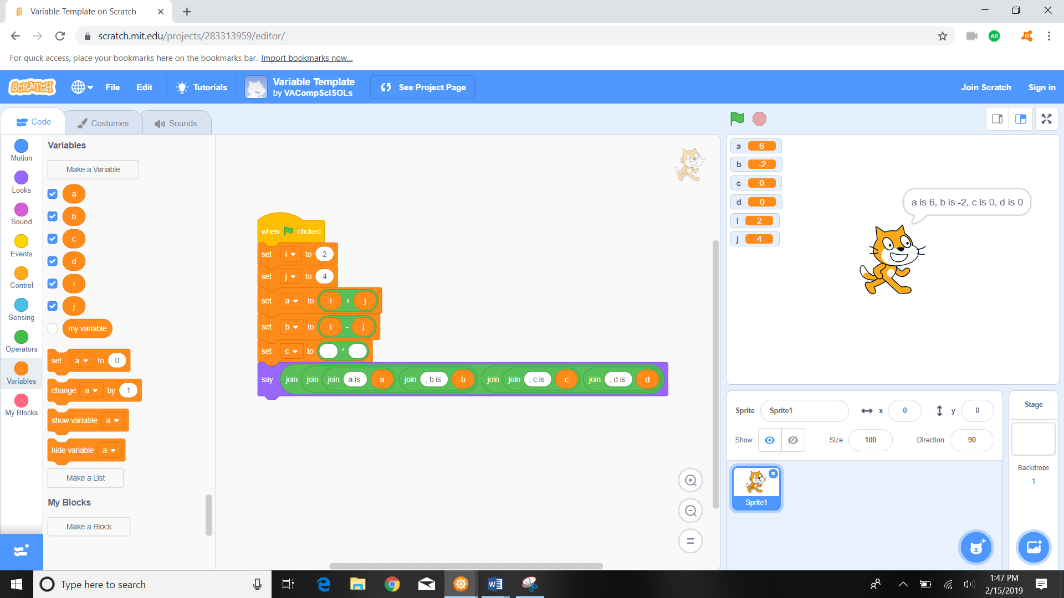

* 1. We then drag the orange i variable into the first open spot within 

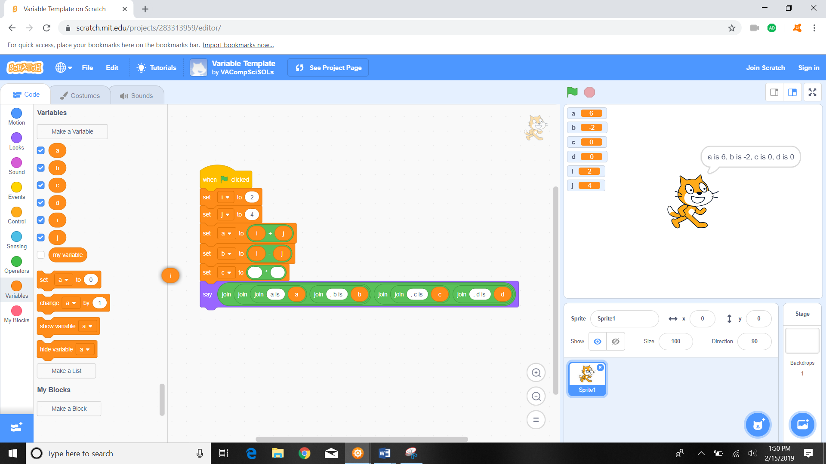

* 1. Once the i variable is dragged into place, the code should look like this:

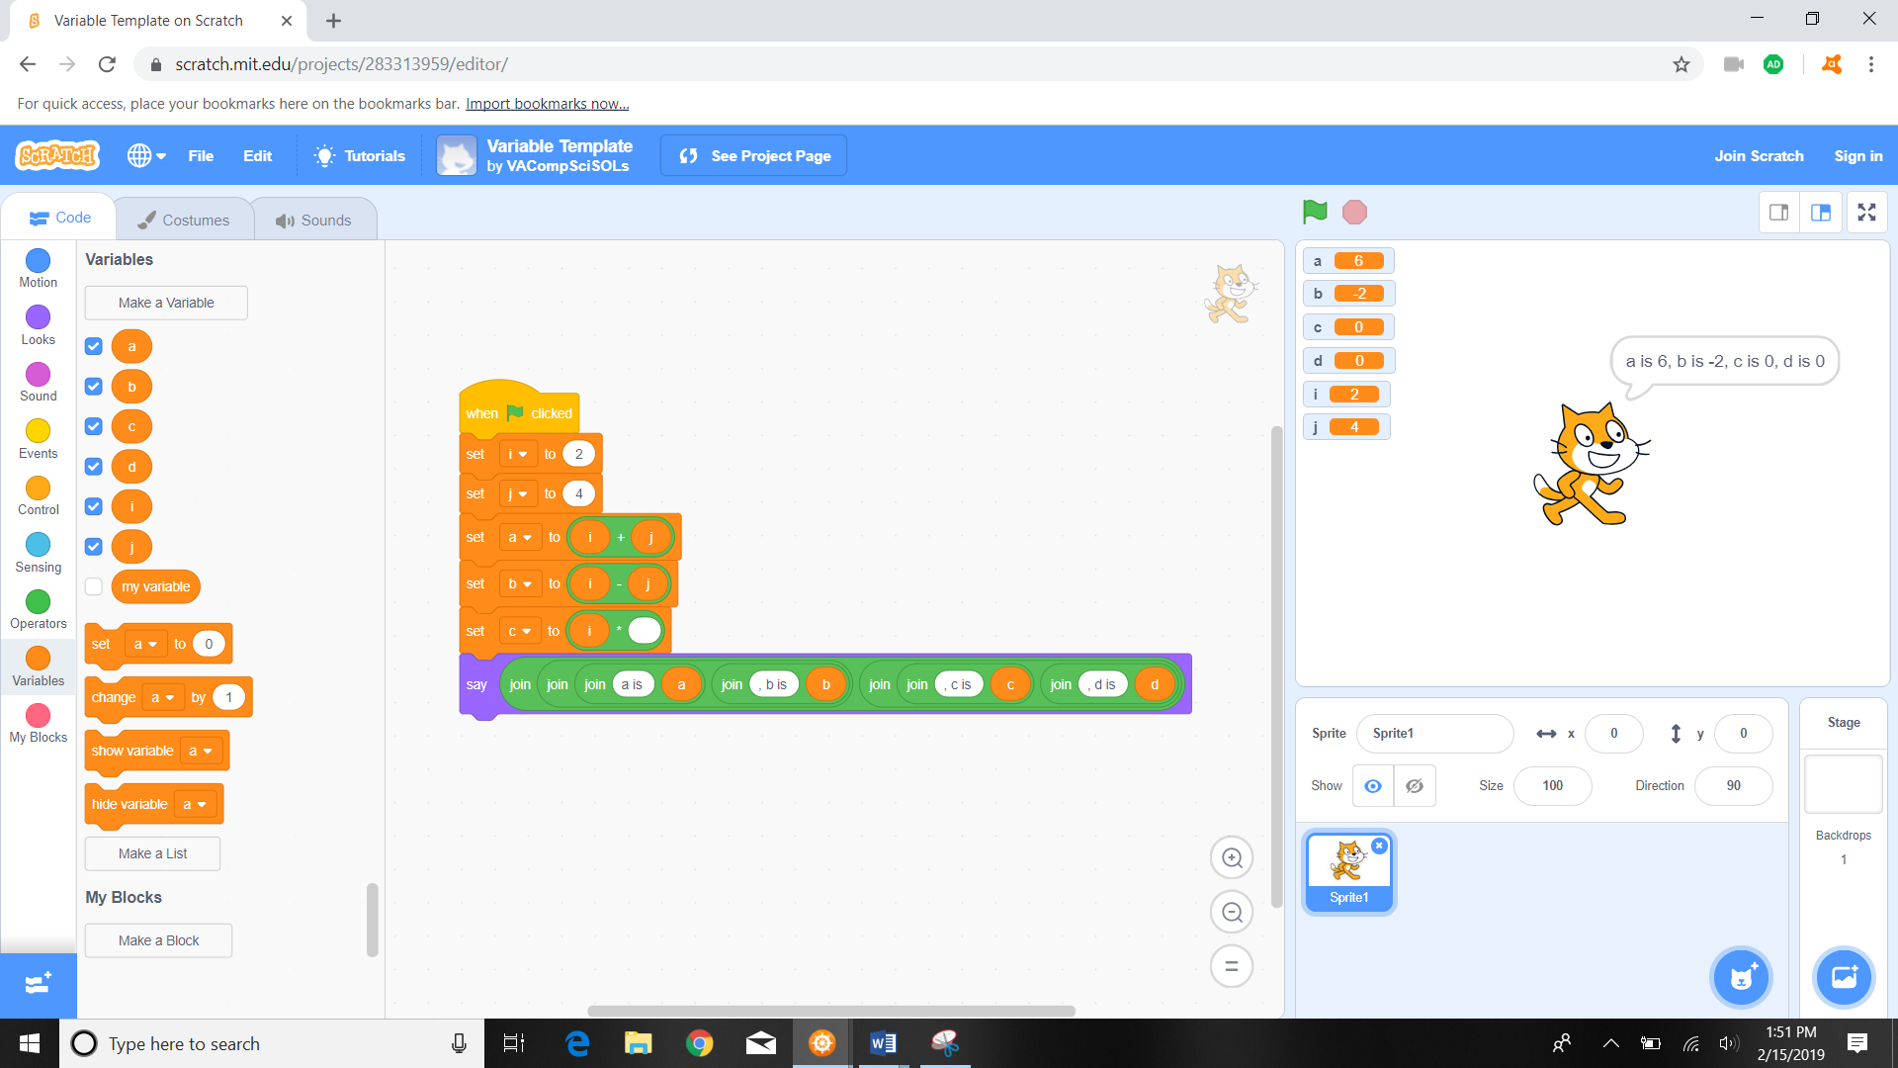

Zoomed in:

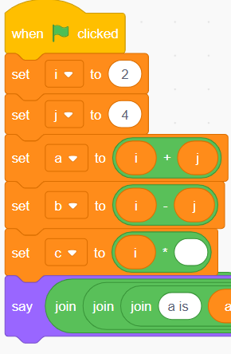

* 1. We now do the same for the j variable, but drag the j variable to the second slot (now the only open slot), and the code should look like this:

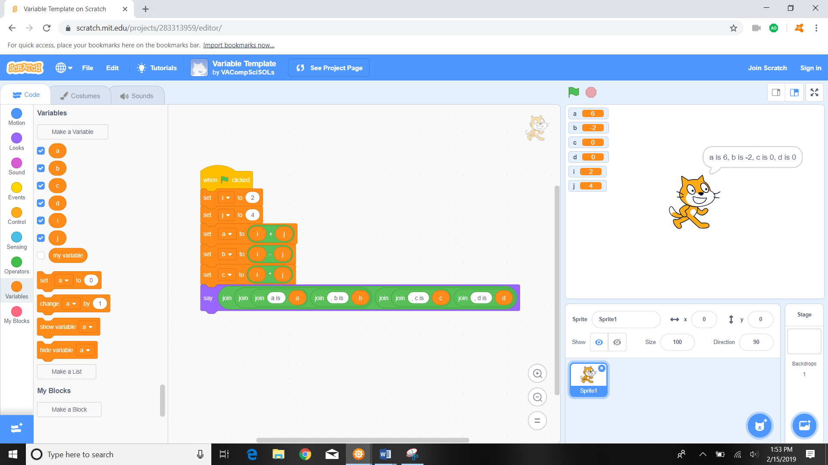

Zoomed in:

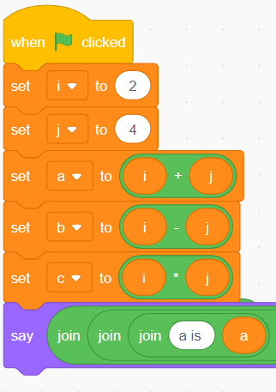

1. Click on the green flag  to run the program and see what changes on the screen.



1. Notice the changes that happen once the green flag is clicked on and the program runs.

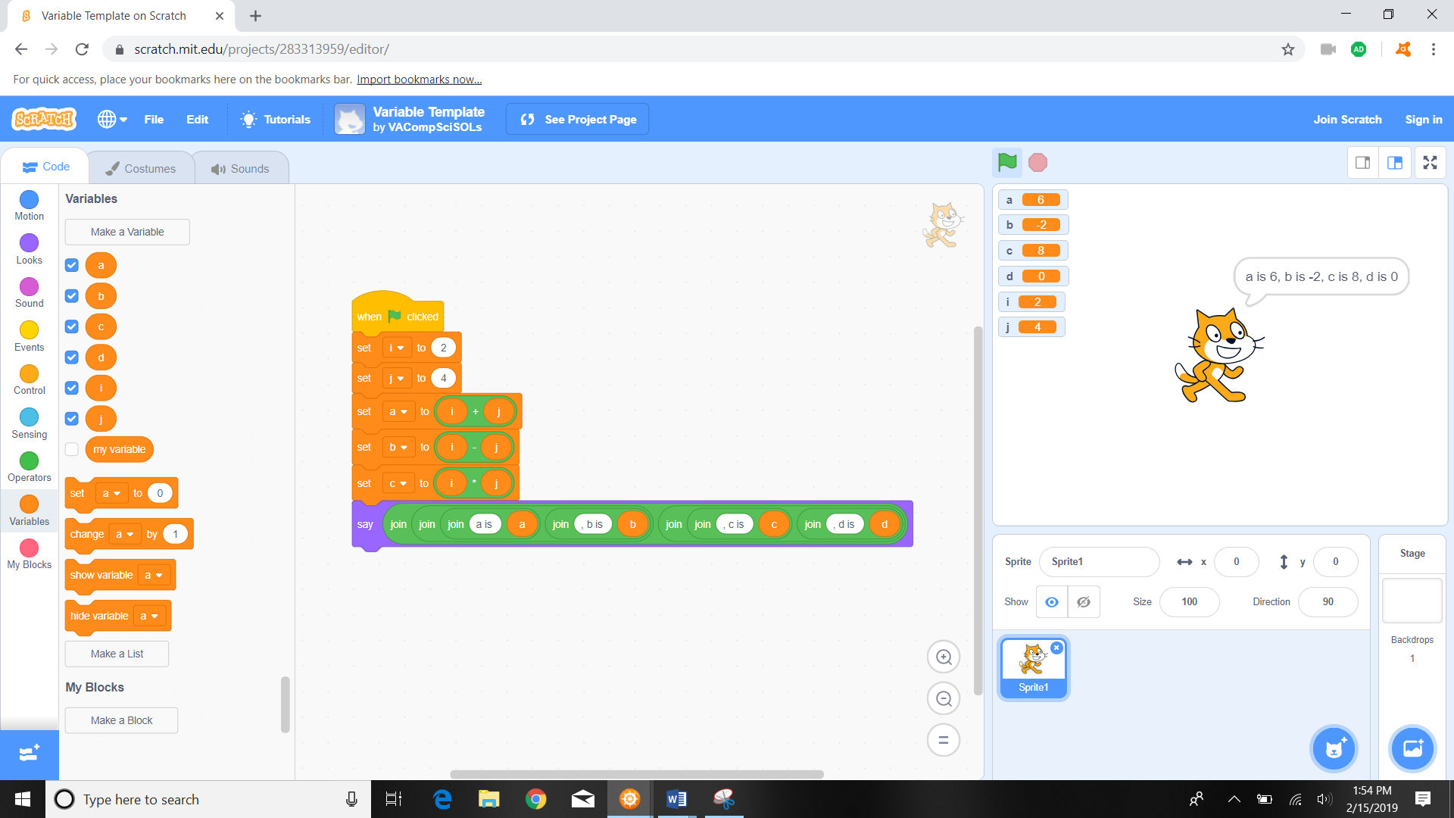

Zoomed in:

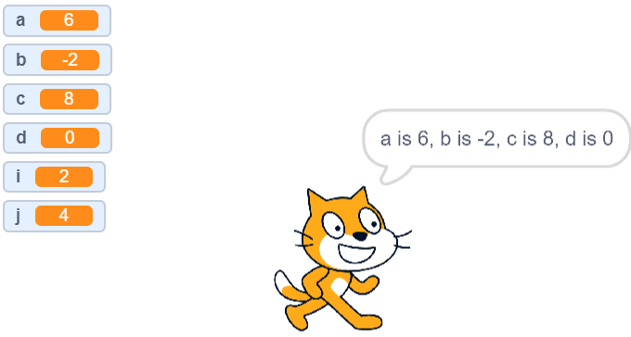

1. \*\*\*\*Advanced Student Variable Challenge\*\*\*\*:
   1. Code a d variable
      1. To do so first detach the last code from the chain in the middle panel

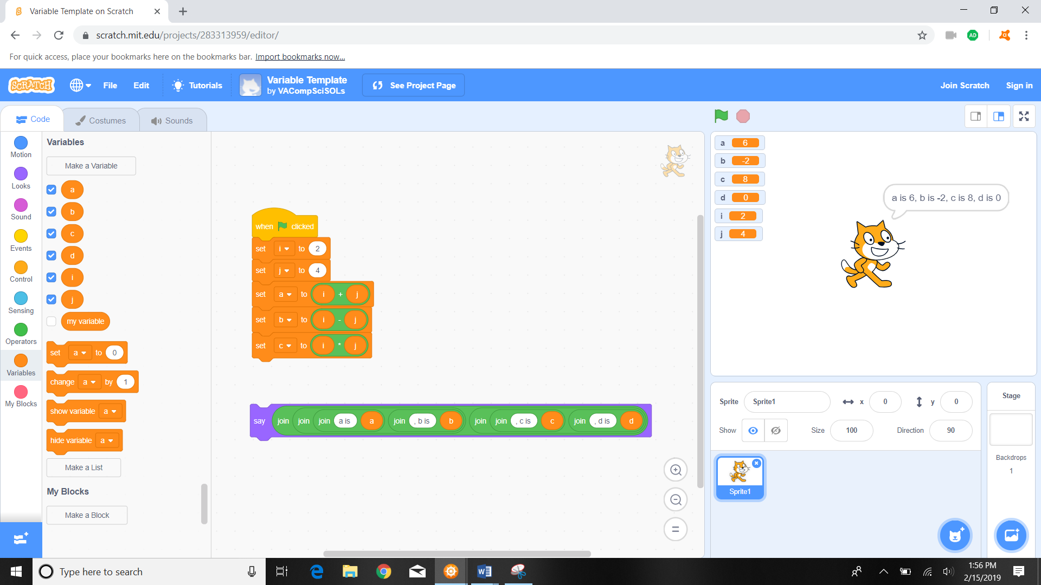

* + 1. on the left most “code” panel we must select the “set a to 0” button and drag it to the middle coding panel screen and attach it below the “set c to i\*j” action.

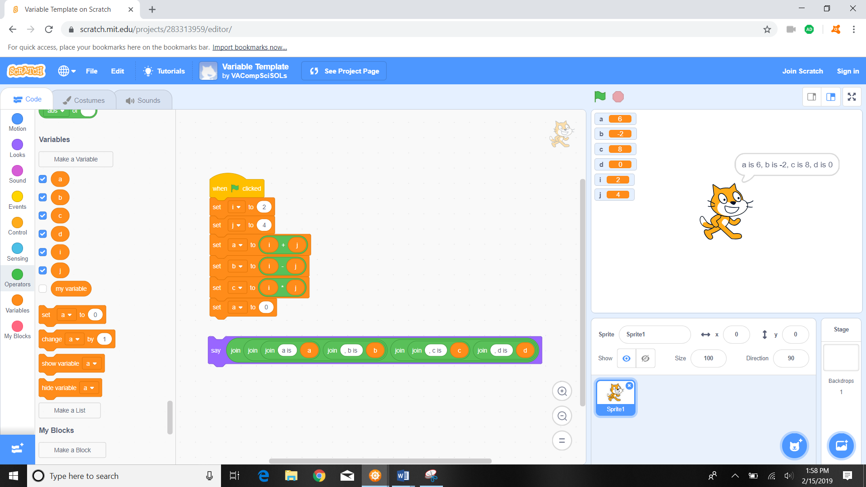

Zoomed in:

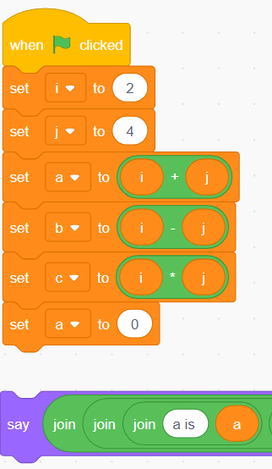

* + 1. using your mouse change the “a” in the drop down to “d”

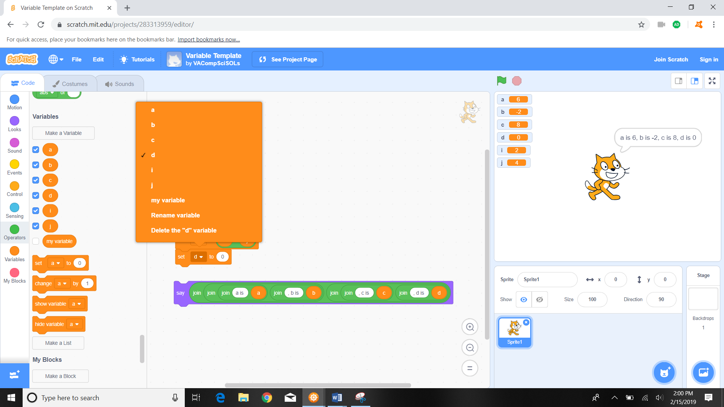

Zoomed in:

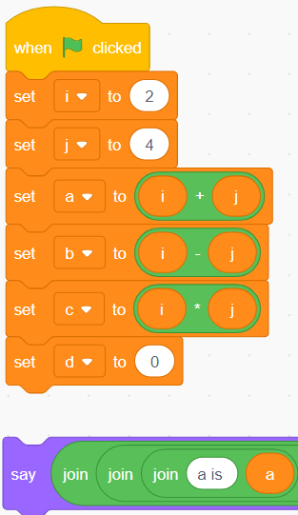

* + 1. On the left most “code” panel we must select the “operators” button and drag the 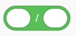 to the middle coding panel screen and attach it to the “set d” action. The code should look like:

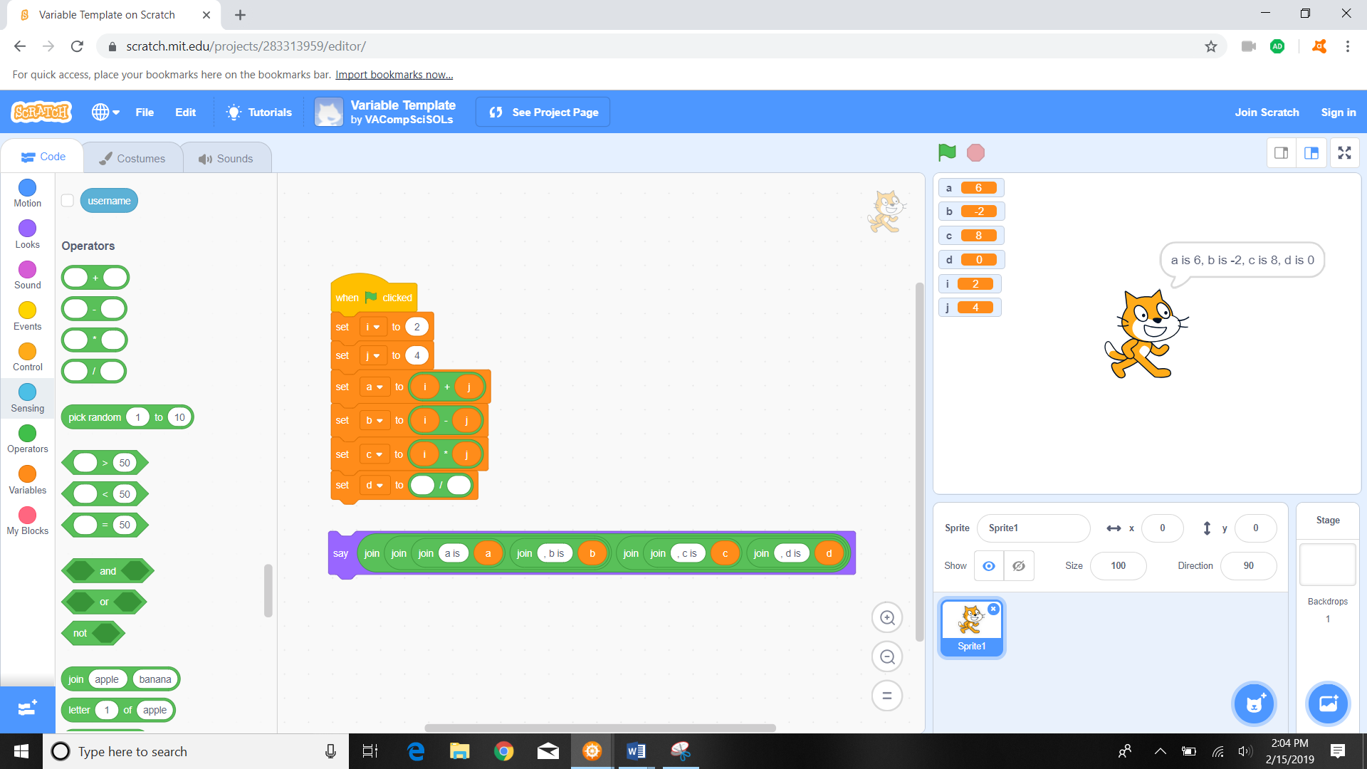

Zoomed in:

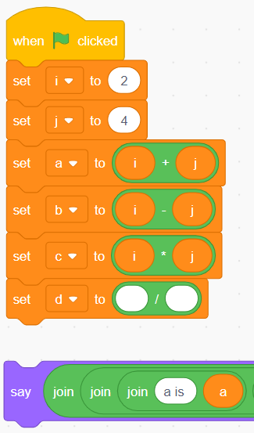

* + 1. We then drag the orange i variable into the first open spot within 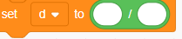. Once the i variable is dragged into place, the code should look like this:

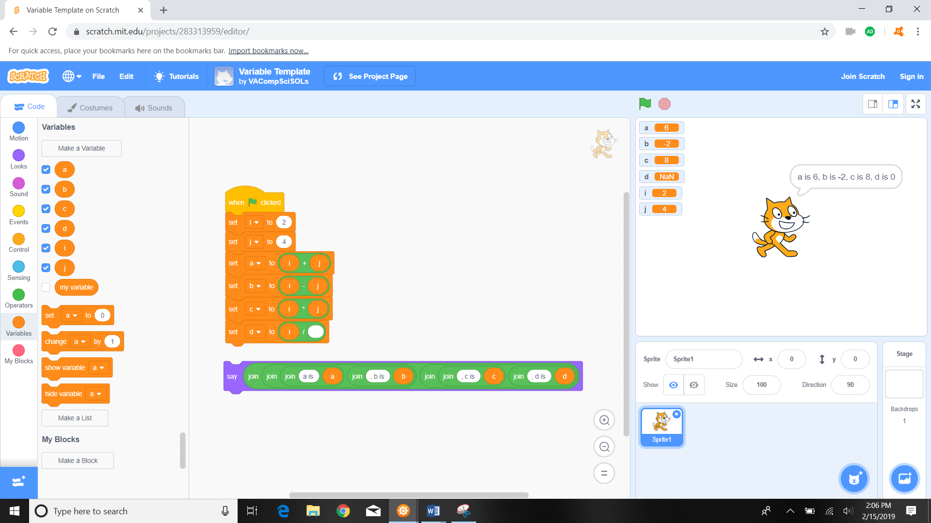

* + 1. We now do the same for the j variable, but drag the j variable to the second slot (now the only open slot), and the code should look like this:

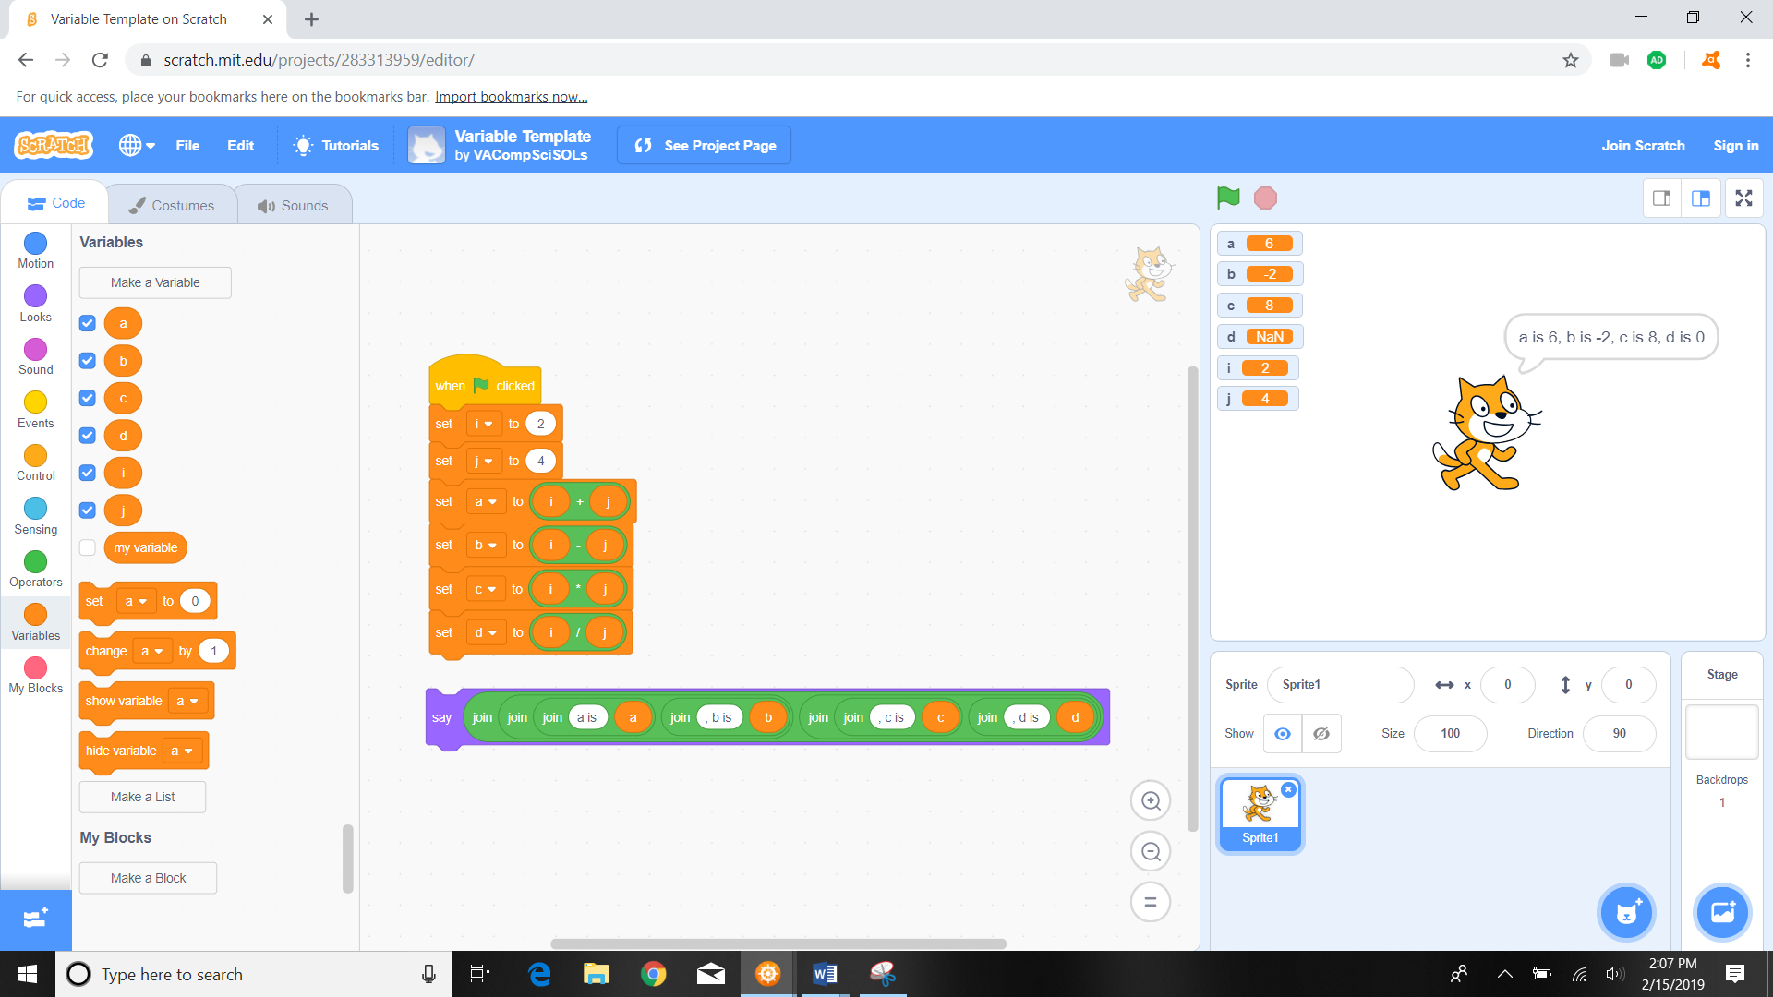

Zoomed in:

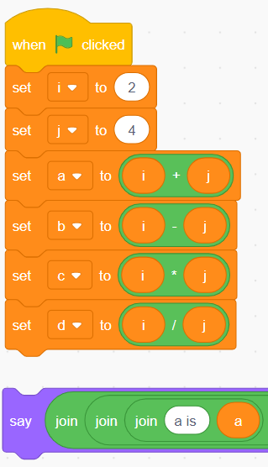

1. Re-attach the “say” action code in the middle panel below the 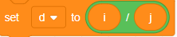 so the code looks like:

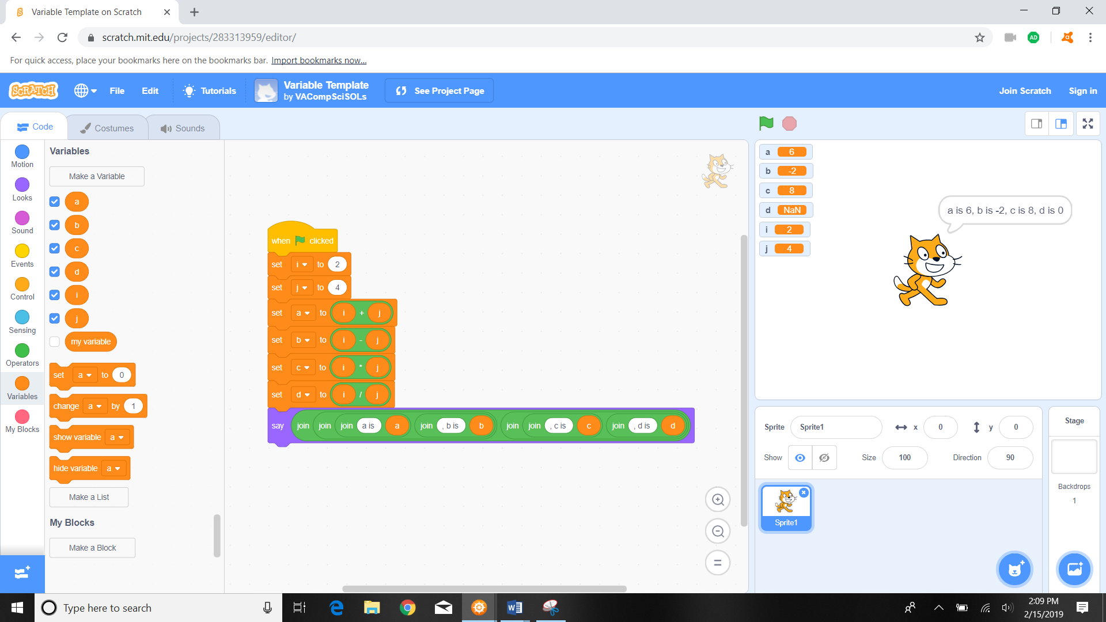

1. Click on the green flag  to run the program and see what changes on the screen.



1. Notice the changes that happen once the green flag is clicked on and the program runs.

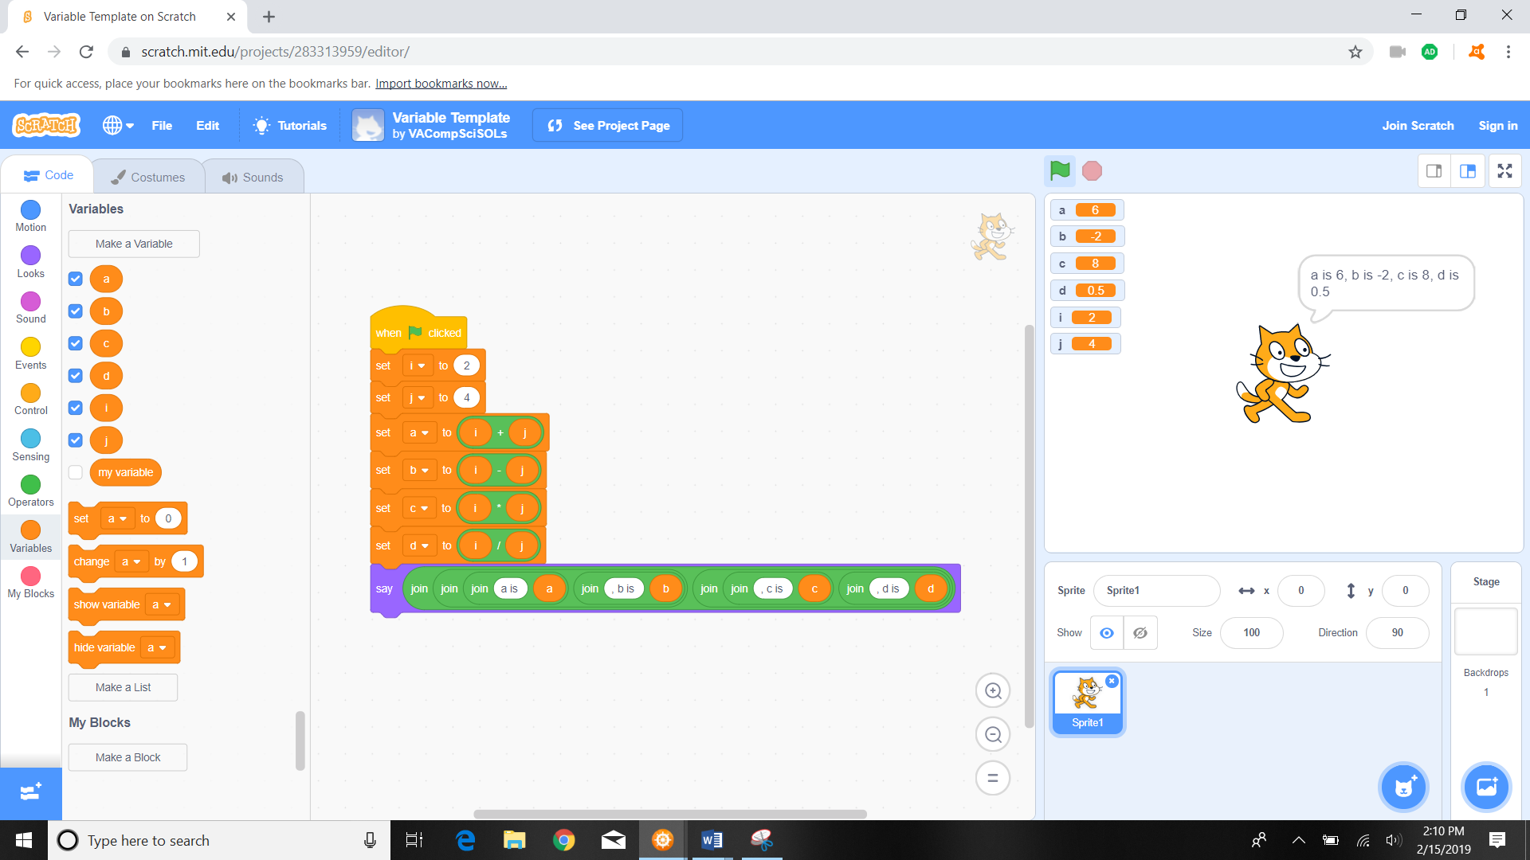

Zoomed in:

